CSS ISLAMIC STUDIES · T3KB
بِسۡمِ ٱللَّهِ ٱلرَّحۡمَٰنِ ٱلرَّحِيمِ
Topic III — The Sirah of the Prophet (PBUH) as Role Model
The Knowledge Base · The Prophet ﷺ as the model for the individual, and as educator, diplomat, military strategist and peace maker
Eleven chapters built from the syllabus and from the thirteen questions set on this topic between 2016 and 2025 — the heaviest topic of the paper — with the contemporary debates, the examiner's record, five likely questions, a numbered one-liner bank and chapter-by-chapter revision notes. Every point carries its evidence — the Quran first, then the Hadith, then the Sirah and the scholars — inside the point itself.
Edition of September 2026 · covers the papers of 2015–2026 · written for CSS 2027 and after
Contents
HOW TO BUILD THE CONTENTS
The Contents below is left empty on purpose. In Microsoft Word, right-click anywhere on the grey line below and choose Update Field → Update entire table → OK. The full table of contents with page numbers will appear.
On a Mac: right-click (or Control-click) the line → Update Field. If you edit the notes later, repeat this step to refresh the page numbers. You can also press Ctrl + A then F9 (Windows) to update every field in the document at once.

How to Use This Document 9
What this topic covers 9
How this document is built 10
Part Zero — The ABC Before the Chapters 11
0.1 The words of this topic 11
0.2 The life on one line 12
0.3 One life, five roles 12
Chapter 1 · The Sirah and the Uswah Hasanah: Why His Life Is the Model 14
1.1 The meaning of Sirah 14
(1) Literal meaning 14
(2) Technical meaning 14
1.2 The Prophet ﷺ is the model — the Quranic basis 14
(1) The excellent example 14
(2) The model of the highest character 14
(3) Obedience to him is obedience to Allah 15
(4) He speaks from revelation 15
(5) A mercy and a messenger for all 15
(6) The last Prophet 16
1.3 What his wife said about his character 16
1.4 The sources of the Sirah 16
(1) The Holy Quran 16
(2) The Hadith 16
(3) The books of Maghazi and Sirah 16
(4) Modern works known in Pakistan 17
1.5 Why only his life can be the universal model 17
(1) The four tests of Syed Sulaiman Nadvi 17
(2) The testimony of history 17
1.6 The Sunnah as law and as model 18
(1) Model in worship and in the world 18
(2) Model for rulers and ruled 18
Chapter 2 · The Prophet ﷺ as a Model for the Individual 19
2.1 Model in faith and worship 19
(1) Constant worship with gratitude 19
(2) Trust in Allah with full use of means 19
2.2 Model in truthfulness and trust 20
(1) Al-Sadiq, Al-Amin — before Prophethood 20
(2) Trust kept even with enemies 20
2.3 Model in simplicity and contentment 20
(1) The mat and the treasury 20
(2) Home and food 20
2.4 Model in family life 20
(1) The best to his family 20
(2) Helping at home 21
(3) Father and grandfather 21
2.5 Model in care for the weak 21
2.6 Model in work and earning 22
2.7 Model in cleanliness, health and time 22
2.8 Model in moderation 22
2.9 Model in speech and manners 23
Chapter 3 · Makarim al-Akhlaq: Tolerance, Forgiveness and Noble Character 24
3.1 The meaning of Akhlaq and Makarim al-Akhlaq 24
(1) Akhlaq 24
(2) Makarim al-Akhlaq 24
3.2 Character as the purpose of the Prophethood 24
3.3 How the Prophet ﷺ 'completed' the morals 25
(1) He gave them a new root — faith and accountability 25
(2) He universalised them — from the tribe to humanity 25
(3) He extended them to enemies 26
(4) He balanced them 26
(5) He demonstrated them — the Quran in practice 26
(6) He built them into institutions 26
3.4 Tolerance and forgiveness — the status in his life 27
(1) The Quranic command to him 27
(2) The grades of tolerance — lowest to highest 27
(3) He never took revenge for himself 28
3.5 Tolerance and forgiveness — the great examples 28
(1) Taif (10th year of Prophethood) 28
(2) 'I was not sent to curse' 28
(3) The Conquest of Makkah (8 AH) — the general amnesty 29
(4) The woman who poisoned him (Khaybar, 7 AH) 29
(5) The Bedouin who urinated in the mosque 29
(6) The Bedouin who pulled his cloak 29
(7) Gentleness in the face of insult 29
(8) Abdullah ibn Ubayy — the leader of the hypocrites 30
3.6 Religious tolerance with non-Muslims 30
(1) The Quranic principles 30
(2) The practice 31
3.7 From noble morals to social peace (the 2025 link) 31
The proof in history 32
Chapter 4 · The Prophet ﷺ as Educator 34
4.1 The first word of revelation was about knowledge 34
4.2 Teaching as the purpose of his mission 34
(1) The four functions — the key verse 34
(2) In his own words: 'sent as a teacher' 35
(3) Knowledge made a duty for all 35
4.3 The institutions he built 36
(1) Dar al-Arqam — the first school (Makkah) 36
(2) Mus'ab ibn Umair — the first teacher sent abroad 36
(3) The Mosque of Madinah and Suffah — the first residential university 36
(4) Literacy through prisoners of war (Badr, 2 AH) 36
(5) Scribes and languages 36
(6) Teachers sent across Arabia 36
4.4 His methods of teaching 36
(1) Gentleness — the best teacher anyone saw 36
(2) Making things easy 37
(3) Questions to awaken the mind 37
(4) Repetition for clarity 37
(5) Practical demonstration 37
(6) Drawings and examples 37
(7) Gradualism 38
(8) Spacing the lessons to avoid boredom 38
(9) Attention to individual differences 38
(10) Encouraging questions and involving women 38
(11) Teaching by character — the teacher as example 38
(12) Every learner a teacher 38
4.5 The result — a generation of teachers 39
Chapter 5 · The Prophet ﷺ as Diplomat 40
5.1 The meaning of diplomacy and its Quranic basis 40
5.2 Diplomatic skill before Prophethood 41
(1) Hilf al-Fudul — the League of the Virtuous 41
(2) The Black Stone (605) 41
5.3 Diplomacy of asylum — the Hijrah to Abyssinia (615) 41
5.4 Diplomacy in Madinah — agreements and alliances 41
5.5 The letters to the rulers (6–7 AH) 41
(1) The letter to Heraclius — the model text 42
(2) The features of the letters 42
5.6 Envoys, delegations and immunity 43
(1) The immunity of envoys 43
(2) The Year of Delegations (9 AH) 43
(3) Hospitality and gifts 43
5.7 The principles of Prophetic diplomacy 43
Chapter 6 · The Prophet ﷺ as Military Strategist 45
6.1 The background — why a Prophet had to lead armies 45
6.2 Ghazwat and Saraya — the numbers 45
6.3 The principles of his military strategy 46
(1) Preparation and deterrence 46
(2) Intelligence (information) 46
(3) Consultation (Shura) 46
(4) Choice of ground and position 47
(5) Discipline and obedience 47
(6) Organisation — the rows (saff) 47
(7) Defensive innovation — the Trench 48
(8) Splitting the enemy alliance 48
(9) Secrecy and surprise 48
(10) Economic pressure 48
(11) Alliances and treaties 48
(12) Speed and pursuit 48
(13) Morale and psychological strength 48
(14) Minimum force 49
6.4 His character as commander in the battlefield (2019) 49
(1) Courage at the front 49
(2) Sharing every hardship 49
(3) Consultation and humility 49
(4) Trust in Allah with full preparation 50
(5) Keeping his word even in war 50
(6) Justice to his own soldiers 50
(7) Mercy to prisoners and the defeated 50
(8) Forgiveness at the moment of victory 50
(9) Patience in setback 50
(10) Never wishing for war 50
6.5 What non-Muslim and military writers say 51
Chapter 7 · The Purpose of the Ghazwat: War for Peace 52
7.1 Jihad and Qital — the terms 52
7.2 The Quranic conditions of war 52
(1) Permission only after persecution 52
(2) Only against those who fight 52
(3) To end persecution 53
(4) For the oppressed 53
(5) Peace as soon as it is offered 53
7.3 The causes of the Ghazwat — each one for peace 54
7.4 The rules of war — peace inside war 54
7.5 The proof — what the Ghazwat produced 55
(1) The least bloodshed in any revolution 55
(2) The goal was guidance, not killing 56
(3) Safe roads — the prophecy fulfilled 56
(4) The enemies became brothers 56
Chapter 8 · The Prophet ﷺ as Peace Maker 57
8.1 Peace is the name of the religion 57
(1) The words 57
(2) Peace as the definition of a Muslim — 'peace and safety' (2018) 57
(3) The sanctity of life 58
8.2 Peace maker before Prophethood 58
8.3 Peace inside Madinah — the Muslim society 58
(1) Ending the war of Aws and Khazraj 58
(2) The Brotherhood — Mu'akhat 59
(3) Abolishing blood feuds 59
(4) Equality — removing the roots of conflict 59
(5) Reconciling quarrels 60
8.4 Reconciliation with the pagans (Mushrikin) 60
8.5 Reconciliation with the Jews 60
8.6 Reconciliation with the Christians 60
8.7 A prophet of peace for the contemporary transnational world (2022) 61
Chapter 9 · The Charter of Madinah as a Social Contract 63
9.1 What the Charter is 63
9.2 The background — Yathrib before the Hijrah 63
9.3 The parties 64
9.4 The main provisions, with its own words 64
(1) One political community 64
(2) Religious freedom 64
(3) The final authority and judiciary 65
(4) Joint defence 65
(5) Madinah a sanctuary 65
(6) Rule of law and personal responsibility 65
9.5 The Charter as a social contract — analysis 66
(1) What a social contract is 66
(2) The elements of a social contract in the Charter 66
(3) How it goes beyond the Western social contract 66
(4) The Charter in operation 67
9.6 Relevance for Pakistan 67
Chapter 10 · The Treaty of Hudaybiyyah and the Peace Agreements of the Prophetic Era 68
10.1 The Treaty of Hudaybiyyah (Dhul Qa'dah 6 AH / March 628) 68
(1) Background 68
(2) The pledge of Ridwan 68
(3) The negotiation 68
(4) The terms 69
(5) The Companions' grief and the Prophet's ﷺ vision 69
(6) 'A clear victory' 70
10.2 Hudaybiyyah as a pact of peace — its results 70
10.3 The peace agreements of the Prophetic era — contents and parties (2025) 70
Chapter 11 · The Battle of Khaybar (7 AH) and Its Benefits 72
11.1 The background 72
11.2 The campaign (Muharram 7 AH / May 628) 72
11.3 The benefits of Khaybar 72
(1) Military and political 72
(2) Economic 72
(3) Social, moral and legal 73
(4) Joy of reunion 73
Part Two — Contemporary Challenges, Narratives and Hot Debates 74
12.1 The Prophet ﷺ as a model for a transnational, multicultural world 74
12.2 Responding to insults against the Prophet ﷺ — the lawful and dignified way 74
12.3 Leadership and management lessons from the Sirah 74
12.4 The Prophet ﷺ as educator in an age of AI and information overload 75
12.5 Just war and the protection of civilians — the Sirah and modern humanitarian law 75
Part Three — The Examiner's Record and Five Likely Questions 77
13.1 Every question on this topic, 2016–2025 77
13.2 What the record teaches 77
13.3 Five likely questions 77
Part Four — The One-Liner Bank 79
One-liners · The Sirah and its sources 79
One-liners · The individual 79
One-liners · Makarim al-Akhlaq, tolerance and forgiveness 79
One-liners · Educator 80
One-liners · Diplomat 80
One-liners · Military strategist and the Ghazwat 81
One-liners · Peace maker, the Charter and the treaties 81
Part Five — Revision Notes · Topic 3 83
R3.0 The topic in eleven lines 83
R3.1 Chapter 1 · The Sirah and the Uswah Hasanah 83
R3.2 Chapter 2 · The individual 83
R3.3 Chapter 3 · Makarim al-Akhlaq, tolerance and forgiveness 84
R3.4 Chapter 4 · Educator 84
R3.5 Chapter 5 · Diplomat 84
R3.6 Chapter 6 · Military strategist and commander 85
R3.7 Chapter 7 · War for peace 85
R3.8 Chapter 8 · Peace maker 85
R3.9 Chapter 9 · Charter of Madinah as social contract 86
R3.10 Chapter 10 · Hudaybiyyah and the peace agreements 86
R3.11 Chapter 11 · Khaybar and its benefits 86
R3.12 Part Two · Today 87
R3.13 The figures to draw 87

How to Use This Document

What this topic covers
Topic 3 carries the syllabus head 'The Sirah of the Prophet ﷺ as role model' — for the individual, and as educator, diplomat, military strategist and peace maker. It is the heaviest topic of the paper: thirteen questions in ten years, almost one every paper.
Syllabus line / past question | Where it is taught
The Sirah as the model; sources of the Sirah | Chapter 1
Role model for the individual | Chapter 2
Tolerance and forgiveness (2020); Makarim al-Akhlaq and social peace (2025) | Chapter 3
Educator (never asked — overdue) | Chapter 4
Diplomat (never asked — overdue) | Chapter 5
Military strategist (2016, 2019, 2023) | Chapter 6
Ghazwat to establish peace (2024) | Chapter 7
Peace maker (2017, 2018, 2022) | Chapter 8
Charter of Madinah as a social contract (2020, 2023) | Chapter 9
Hudaybiyyah (2021); peace agreements and their parties (2025) | Chapter 10
Benefits of Khaybar (2021) | Chapter 11

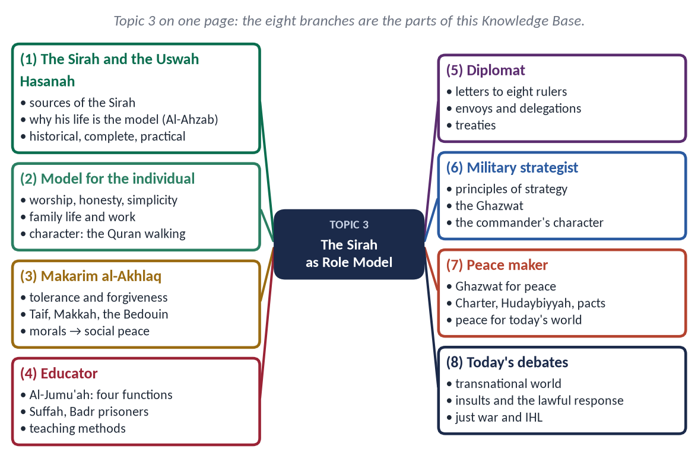
Figure 1 · Topic 3 on one page. The eight branches are the parts of this Knowledge Base.

How this document is built
1. Part Zero — the ABC: the words of the topic and the life of the Prophet ﷺ on one timeline.
2. Part One — eleven chapters, divided down to four levels of headings. In every point the evidence comes in one order: the Quran first, then the Hadith, then the Sirah and the scholars.
3. At-a-glance charts — after a long section, a chart repeats only the names of its points, grouped by aspect, so that the whole section can be revised in one look.
4. Part Two — contemporary challenges and hot debates.
5. Part Three — the examiner's record and five likely questions.
6. Part Four — the numbered one-liner bank.
7. Part Five — the revision notes: every chapter in compressed, exam-night form.
EXAMINER'S EYE · THIS TOPIC IN THE PAPER
Thirteen questions: peace six times (2017, 2018, 2021, 2022, 2024, 2025), military strategy three times (2016, 2019, 2023), the Charter of Madinah twice (2020, 2023), character twice (2020, 2025). Educator and Diplomat are in the syllabus but have never been asked — prepare them; they are the most likely surprise.

Part Zero — The ABC Before the Chapters

0.1 The words of this topic
Term | Arabic | Meaning in this topic
Sirah | سِيرَة | The life of the Prophet ﷺ; literally 'way of going', conduct.
Uswah Hasanah | أُسْوَةٌ حَسَنَة | The excellent example to be followed (Al-Ahzab).
Shama'il | شَمَائِل | The Prophet's ﷺ appearance, habits and manners.
Maghazi | مَغَازِي | The military expeditions — the early name of Sirah books.
Akhlaq | أَخْلَاق | Character, morals (singular khuluq).
Makarim al-Akhlaq | مَكَارِمُ الْأَخْلَاق | The noblest morals — the highest grade of character.
Hilm | حِلْم | Forbearance: control of anger when one has power.
'Afw / Safh | عَفْو / صَفْح | Pardon / overlooking the wrong completely.
Mu'allim | مُعَلِّم | Teacher — the Prophet's ﷺ description of himself (Muslim).
Tazkiyah | تَزْكِيَة | Purification of the soul — one of his four functions (Al-Jumu'ah).
Ghazwah | غَزْوَة | An expedition led by the Prophet ﷺ in person.
Sariyyah | سَرِيَّة | An expedition sent under a Companion.
Jihad / Qital | جِهَاد / قِتَال | Striving (wide) / armed fighting (narrow).
Sulh | صُلْح | Peace treaty, reconciliation.
Mu'ahadah | مُعَاهَدَة | A covenant, pact.
Mithaq al-Madinah | مِيثَاقُ الْمَدِينَة | The Charter of Madinah; also Sahifat al-Madinah.
Ummah | أُمَّة | Community; in the Charter, the one political community of Madinah.
Mu'akhat | مُؤَاخَاة | The brotherhood between Muhajirin and Ansar.
Wufud | وُفُود | Delegations — 9 AH is 'the Year of Delegations'.

0.2 The life on one line
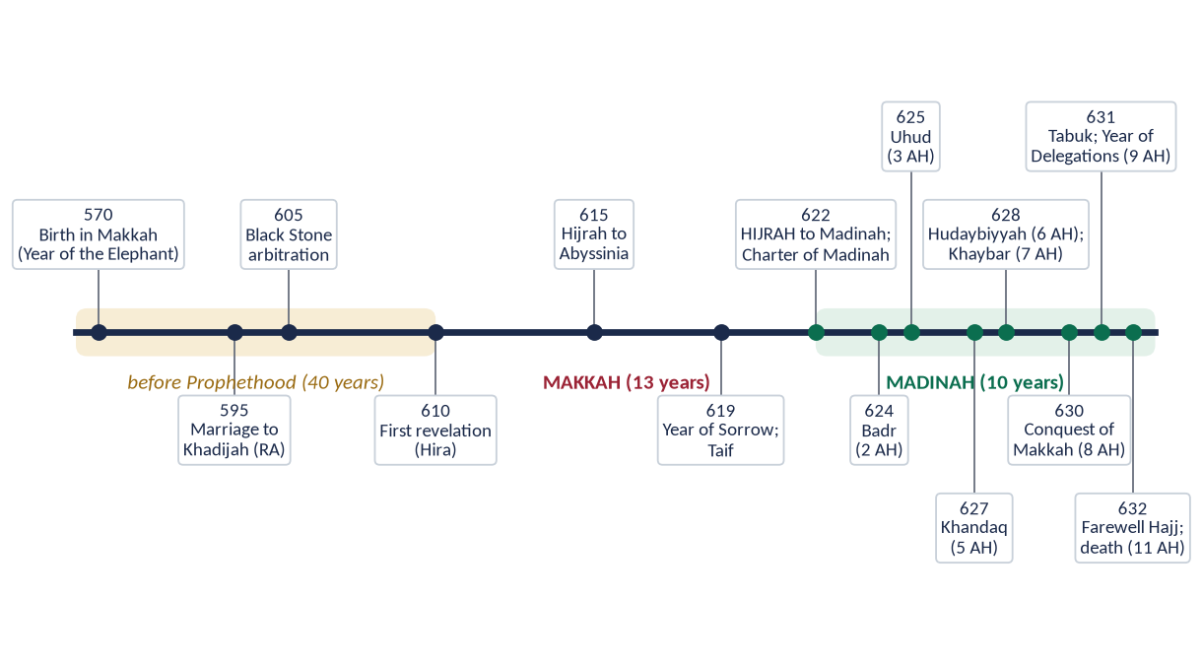
Figure 2 · The life of the Prophet ﷺ: forty years before Prophethood, thirteen in Makkah, ten in Madinah.
Every role in this topic belongs to a stage of this line. The individual is seen across all 63 years; the educator from the first revelation (610); the diplomat, strategist and peace maker mainly in the ten Madinan years, when the Prophet ﷺ was also head of a state.

0.3 One life, five roles
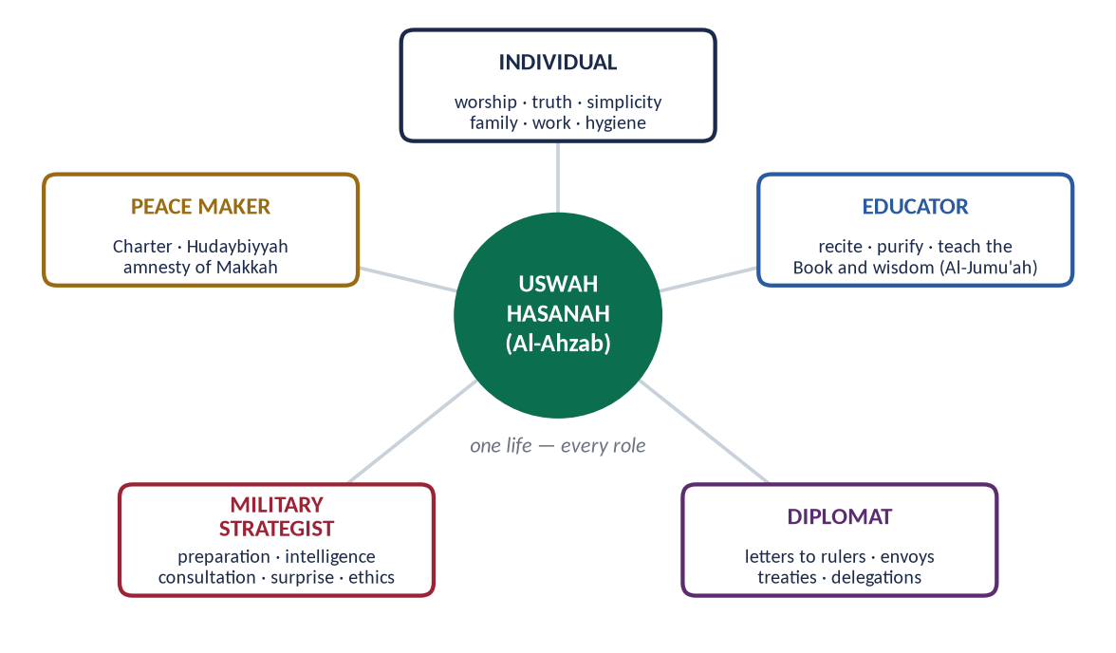
Figure 3 · The five roles of the syllabus meet in one person — the Uswah Hasanah.
REMEMBER · THE OPENING OF EVERY SIRAH ANSWER
Start with Al-Ahzab ('in the Messenger of Allah you have an excellent example'), add Al-Anbiya ('a mercy to all the worlds') for peace and character, or Al-Jumu'ah (his four functions) for the educator. Then turn at once to the role the question names.

Chapter 1 · The Sirah and the Uswah Hasanah: Why His Life Is the Model

1.1 The meaning of Sirah

(1) Literal meaning
Sirah (سِيرَة) comes from sara — 'to go, to travel'. It means the way a person goes through life: his conduct and manner of living.

(2) Technical meaning
Sirah is the record of the life of the Prophet Muhammad ﷺ — his birth, family, character, message, struggles, battles, treaties and death — written as a guide to be followed, not only as history.

1.2 The Prophet ﷺ is the model — the Quranic basis

(1) The excellent example
✦ QURAN
﴿لَّقَدۡ كَانَ لَكُمۡ فِي رَسُولِ ٱللَّهِ أُسۡوَةٌ حَسَنَةٞ لِّمَن كَانَ يَرۡجُواْ ٱللَّهَ وَٱلۡيَوۡمَ ٱلۡأٓخِرَ وَذَكَرَ ٱللَّهَ كَثِيرٗا﴾
“There has certainly been for you in the Messenger of Allah an excellent pattern for anyone whose hope is in Allah and the Last Day and [who] remembers Allah often.” (Al-Ahzab, Quran)
➜ The Prophet ﷺ is the Uswah Hasanah — the excellent pattern for everyone who hopes for Allah and the Last Day. The verse came during the Battle of the Trench, when he was digging with his own hands: the model is shown in hardship, not only in ease.

(2) The model of the highest character
✦ QURAN
﴿وَإِنَّكَ لَعَلَىٰ خُلُقٍ عَظِيمٖ﴾
“And indeed, you are of a great moral character.” (Al-Qalam, Quran)
➜ 'You are of a great moral character' — Allah's own testimony to his character.

(3) Obedience to him is obedience to Allah
✦ QURAN
﴿مَّن يُطِعِ ٱلرَّسُولَ فَقَدۡ أَطَاعَ ٱللَّهَۖ وَمَن تَوَلَّىٰ فَمَآ أَرۡسَلۡنَٰكَ عَلَيۡهِمۡ حَفِيظٗا﴾
“He who obeys the Messenger has obeyed Allah; but those who turn away - We have not sent you over them as a guardian.” (An-Nisa, Quran)
➜ 'Whoever obeys the Messenger has obeyed Allah' — his Sunnah is binding, not optional.

(4) He speaks from revelation
✦ QURAN
﴿وَمَا يَنطِقُ عَنِ ٱلۡهَوَىٰٓ ۝ إِنۡ هُوَ إِلَّا وَحۡيٞ يُوحَىٰ﴾
“Nor does he speak from [his own] inclination. It is not but a revelation revealed.” (An-Najm, Quran)
➜ He does not speak from his own desire; it is revelation revealed — the guidance in his life is divine guidance.

(5) A mercy and a messenger for all
✦ QURAN
﴿وَمَآ أَرۡسَلۡنَٰكَ إِلَّا رَحۡمَةٗ لِّلۡعَٰلَمِينَ﴾
“And We have not sent you, [O Muhammad], except as a mercy to the worlds.” (Al-Anbiya, Quran)
➜ He was sent as a mercy to all the worlds — so his model is universal, for Muslims and non-Muslims alike.

✦ QURAN
﴿وَمَآ أَرۡسَلۡنَٰكَ إِلَّا كَآفَّةٗ لِّلنَّاسِ بَشِيرٗا وَنَذِيرٗا وَلَٰكِنَّ أَكۡثَرَ ٱلنَّاسِ لَا يَعۡلَمُونَ﴾
“And We have not sent you except comprehensively to mankind as a bringer of good tidings and a warner. But most of the people do not know.” (Saba, Quran)
➜ Sent to all mankind as a bringer of good news and a warner.

(6) The last Prophet
✦ QURAN
﴿مَّا كَانَ مُحَمَّدٌ أَبَآ أَحَدٖ مِّن رِّجَالِكُمۡ وَلَٰكِن رَّسُولَ ٱللَّهِ وَخَاتَمَ ٱلنَّبِيِّـۧنَۗ وَكَانَ ٱللَّهُ بِكُلِّ شَيۡءٍ عَلِيمٗا﴾
“Muhammad is not the father of [any] one of your men, but [he is] the Messenger of Allah and last of the prophets. And ever is Allah, of all things, Knowing.” (Al-Ahzab, Quran)
➜ He is the Seal of the Prophets (Khatam an-Nabiyyin); no new model will come, so his must serve every age.

1.3 What his wife said about his character
✦ HADITH
كَانَ خُلُقُهُ الْقُرْآنَ
“His character was the Quran.” (Muslim)
➜ Hazrat Aishah (RA), who knew his private life best, summed him up in four words: he was the Quran in practice.

1.4 The sources of the Sirah

(1) The Holy Quran
The first and most certain source. It records his character, the Hijrah, Badr (Al-Anfal), Uhud (Aal-e-Imran), the Trench (Al-Ahzab), Hudaybiyyah (Al-Fath) and Tabuk (At-Tawbah).

(2) The Hadith
The collections — Al-Bukhari, Muslim and the others — carry thousands of reports of his words and deeds with chains of narrators. Books of Shama'il (شَمَائِل) — above all Al-Shama'il al-Muhammadiyyah of Imam al-Tirmidhi — describe his appearance and habits.

(3) The books of Maghazi and Sirah
Author | Died | Work and importance
Urwah ibn al-Zubayr | 94 AH | Among the first collectors of the Maghazi
Ibn Shihab al-Zuhri | 124 AH | Organised the Maghazi; teacher of Ibn Ishaq
Muhammad ibn Ishaq | 151 AH | The first complete Sirah (Sirat Rasul Allah)
Ibn Hisham | 218 AH | Edited Ibn Ishaq — Al-Sirah al-Nabawiyyah, the standard text
Al-Waqidi | 207 AH | Kitab al-Maghazi — detail of the expeditions
Ibn Sa'd | 230 AH | Al-Tabaqat al-Kubra — the Prophet ﷺ and the Companions
Qadi Iyad | 544 AH | Al-Shifa — his rights and qualities
Ibn al-Qayyim | 751 AH | Zad al-Ma'ad — the guidance in his life

(4) Modern works known in Pakistan
Allama Shibli Nomani and Syed Sulaiman Nadvi — Sirat-un-Nabi; Qazi Muhammad Sulaiman Mansurpuri — Rahmatul-lil-Alamin; Safi-ur-Rahman Mubarakpuri — Al-Raheeq al-Makhtum (first prize, Muslim World League, 1979); Dr Muhammad Hamidullah — The Prophet's Establishing a State, The Battlefields of the Prophet; Martin Lings — Muhammad: His Life Based on the Earliest Sources.

1.5 Why only his life can be the universal model

(1) The four tests of Syed Sulaiman Nadvi
✦ SCHOLARLY VIEW
Syed Sulaiman Nadvi · Khutbat-e-Madras
In his Madras lectures (1925), Nadvi argued that a life can be a model for all humanity only if it passes four tests: it must be historical (fully recorded and reliable), comprehensive (covering every side of life), complete (known from birth to death, private and public), and practical (lived, not only preached). He showed that only the life of the Prophet ﷺ passes all four.
➜ The strongest analytical frame for any 'role model' question.

Test | Meaning
Historical (تاریخیت) | Every detail recorded with chains of narration — not myth or legend.
Comprehensive (جامعیت) | Father, husband, trader, teacher, judge, general, ruler — every role in one life.
Complete (کاملیت) | Private and public life both open: his wives reported his home life.
Practical (عملیت) | He did what he taught: he dug the trench, fasted, forgave, gave away his wealth.

(2) The testimony of history
✦ SCHOLARLY VIEW
Michael H. Hart · The 100: A Ranking of the Most Influential Persons in History (1978)
“My choice of Muhammad to lead the list of the world's most influential persons may surprise some readers and may be questioned by others, but he was the only man in history who was supremely successful on both the religious and secular levels.”
➜ A neutral historian's verdict — useful in any conclusion.

✦ SCHOLARLY VIEW
Allama Muhammad Iqbal · Bang-e-Dra
Iqbal's line 'Ki Muhammad se wafa tu ne to hum tere hain' makes loyalty to the Prophet ﷺ the key to all success — the individual and the nation rise by following him.
➜ The Pakistani poet of the Sirah.

1.6 The Sunnah as law and as model

(1) Model in worship and in the world
The Sirah is not only for the mosque. It shows how to trade (as the trusted merchant of Khadijah's caravans), how to live in a family, how to govern, how to fight and how to make peace.

(2) Model for rulers and ruled
He was ruler and servant at once: he judged, taxed, signed treaties and led armies, yet mended his own shoes.
TRAP · DO NOT WRITE A BIOGRAPHY
A question on 'the Prophet ﷺ as ____' does not want a life story from birth to death. Take only the events that prove the role asked, arrange them as principles (headings), and prove each with the Quran, the Hadith and one event of the Sirah.

Chapter 2 · The Prophet ﷺ as a Model for the Individual
The syllabus puts 'the individual' first: before he led a state, he was a perfect person.

2.1 Model in faith and worship

(1) Constant worship with gratitude
✦ QURAN
﴿قُمِ ٱلَّيۡلَ إِلَّا قَلِيلٗا ۝ نِّصۡفَهُۥٓ أَوِ ٱنقُصۡ مِنۡهُ قَلِيلًا ۝ أَوۡ زِدۡ عَلَيۡهِ وَرَتِّلِ ٱلۡقُرۡءَانَ تَرۡتِيلًا﴾
“Arise [to pray] the night, except for a little. Half of it - or subtract from it a little. Or add to it, and recite the Qur'an with measured recitation.” (Al-Muzzammil, Quran)
➜ 'Stand in prayer at night, except a little' — the night prayer was his daily habit.

✦ HADITH
أَفَلَا أَكُونُ عَبْدًا شَكُورًا
“Should I not be a grateful servant?” (Al-Bukhari and Muslim)
➜ He stood in night prayer until his feet swelled; when asked why, since he was forgiven, he gave this answer — worship is gratitude, not only duty.

(2) Trust in Allah with full use of means
✦ HADITH
اعْقِلْهَا وَتَوَكَّلْ
“Tie it, and then trust in Allah.” (Al-Tirmidhi)
➜ To a man who left his camel untied 'trusting in Allah': tawakkul (تَوَكُّل) follows effort, it does not replace it.

In the cave of Thawr, with the enemy at the mouth, he said to Abu Bakr (RA): 'Do not grieve; Allah is with us' (At-Tawbah) — after planning every detail of the Hijrah.

2.2 Model in truthfulness and trust

(1) Al-Sadiq, Al-Amin — before Prophethood
✦ HADITH
أَرَأَيْتُمْ لَوْ أَخْبَرْتُكُمْ أَنَّ خَيْلًا بِالْوَادِي تُرِيدُ أَنْ تُغِيرَ عَلَيْكُمْ، أَكُنْتُمْ مُصَدِّقِيَّ؟ قَالُوا: نَعَمْ، مَا جَرَّبْنَا عَلَيْكَ إِلَّا صِدْقًا
“'If I told you that horsemen in the valley were about to attack you, would you believe me?' They said: 'Yes, we have never found you anything but truthful.'” (Al-Bukhari)
➜ On the hill of Safa, his enemies admitted his truthfulness before they rejected his message.

(2) Trust kept even with enemies
On the night of the Hijrah the Quraysh were plotting to kill him, yet their deposits were in his keeping. He left Ali (RA) behind to return every trust to its owner.

2.3 Model in simplicity and contentment

(1) The mat and the treasury
✦ HADITH
أَمَا تَرْضَى أَنْ تَكُونَ لَهُمُ الدُّنْيَا وَلَنَا الْآخِرَةُ
“Are you not pleased that they have this world and we have the Hereafter?” (Al-Bukhari and Muslim)
➜ Umar (RA) wept to see the mat's marks on his side while Caesar and Chosroes lived in luxury; this was the reply of the ruler of Arabia.

(2) Home and food
Hazrat Aishah (RA) reported that two months would pass without a fire being lit in his house; the family lived on dates and water (Al-Bukhari and Muslim). At his death his armour was pledged with a Jew for barley (Al-Bukhari).

2.4 Model in family life

(1) The best to his family
✦ QURAN
﴿… وَعَاشِرُوهُنَّ بِٱلۡمَعۡرُوفِۚ …﴾
“And live with them in kindness.” (An-Nisa, Quran)
➜ 'Live with them (your wives) in kindness.'

✦ HADITH
خَيْرُكُمْ خَيْرُكُمْ لِأَهْلِهِ، وَأَنَا خَيْرُكُمْ لِأَهْلِي
“The best of you is the best to his family, and I am the best of you to my family.” (Al-Tirmidhi)
➜ Goodness is tested at home, not in public.

(2) Helping at home
✦ HADITH
كَانَ يَكُونُ فِي مِهْنَةِ أَهْلِهِ، فَإِذَا حَضَرَتِ الصَّلَاةُ خَرَجَ إِلَى الصَّلَاةِ
“He used to be in the service of his family, and when the time of prayer came he went out to pray.” (Al-Bukhari)
➜ Hazrat Aishah (RA): he mended his clothes, milked the goat and served himself — no work is beneath a man.

(3) Father and grandfather
He stood to greet his daughter Fatimah (RA) and kissed her; he carried Hasan and Husain (RA) on his shoulders and lengthened a prostration while a grandchild rode on his back. He wept at the death of his son Ibrahim and said, 'The eye weeps and the heart grieves, but we say only what pleases our Lord' (Al-Bukhari).

2.5 Model in care for the weak
✦ HADITH
أَنَا وَكَافِلُ الْيَتِيمِ فِي الْجَنَّةِ هَكَذَا
“I and the one who looks after an orphan will be in Paradise like this — and he held up two fingers together.” (Al-Bukhari)
➜ He was himself an orphan; he made care of orphans a road to his company in Paradise.

✦ HADITH
لَيْسَ مِنَّا مَنْ لَمْ يَرْحَمْ صَغِيرَنَا وَيُوَقِّرْ كَبِيرَنَا
“He is not one of us who does not show mercy to our young and respect to our elders.” (Al-Tirmidhi)
➜ Mercy to children and respect for elders are marks of the Muslim.

His freed slave Zayd ibn Harithah (RA) preferred to stay with him rather than go home with his own father — a slave chose his 'master' over freedom because of his kindness.

2.6 Model in work and earning
✦ HADITH
مَا أَكَلَ أَحَدٌ طَعَامًا قَطُّ خَيْرًا مِنْ أَنْ يَأْكُلَ مِنْ عَمَلِ يَدِهِ
“No one has ever eaten better food than what he eats from the work of his own hands.” (Al-Bukhari)
➜ Honest labour is honour.

He grazed sheep in his youth ('Every prophet grazed sheep', Al-Bukhari), traded honestly for Khadijah (RA), carried bricks for the Mosque of Madinah and dug the Trench with a stone tied to his stomach from hunger (Al-Bukhari).

2.7 Model in cleanliness, health and time
✦ HADITH
الطُّهُورُ شَطْرُ الْإِيمَانِ
“Purity is half of faith.” (Muslim)
➜ He loved the miswak, perfume and clean clothes.

✦ HADITH
نِعْمَتَانِ مَغْبُونٌ فِيهِمَا كَثِيرٌ مِنَ النَّاسِ: الصِّحَّةُ وَالْفَرَاغُ
“Two blessings that many people waste: health and free time.” (Al-Bukhari)
➜ Time management from the Sunnah.

He ate little ('the son of Adam fills no vessel worse than his stomach', Al-Tirmidhi), slept early after Isha, rose for Tahajjud, and raced with Hazrat Aishah (RA) — a balanced and healthy routine.

2.8 Model in moderation
✦ QURAN
﴿وَكَذَٰلِكَ جَعَلۡنَٰكُمۡ أُمَّةٗ وَسَطٗا لِّتَكُونُواْ شُهَدَآءَ عَلَى ٱلنَّاسِ وَيَكُونَ ٱلرَّسُولُ عَلَيۡكُمۡ شَهِيدٗاۗ …﴾
“And thus We have made you a middle (just) nation, that you may be witnesses over mankind and the Messenger a witness over you.” (Al-Baqarah, Quran)
➜ The Muslims are a middle nation (ummatan wasata) — balance is the mark of the Sunnah.

✦ HADITH
إِنَّ الدِّينَ يُسْرٌ، وَلَنْ يُشَادَّ الدِّينَ أَحَدٌ إِلَّا غَلَبَهُ
“The religion is easy, and no one makes it hard except that it overcomes him.” (Al-Bukhari)
➜ He fasted and broke fasts, prayed and slept, married and lived in the world — no extremism in worship.

2.9 Model in speech and manners
He smiled much, spoke clearly and briefly, never cursed or used foul words (Al-Bukhari), greeted children first, visited the sick — even a Jewish boy who served him — and accepted invitations from slaves.
✦ HADITH
لَا يُؤْمِنُ أَحَدُكُمْ حَتَّى يُحِبَّ لِأَخِيهِ مَا يُحِبُّ لِنَفْسِهِ
“None of you truly believes until he loves for his brother what he loves for himself.” (Al-Bukhari and Muslim)
➜ The golden rule of social manners.

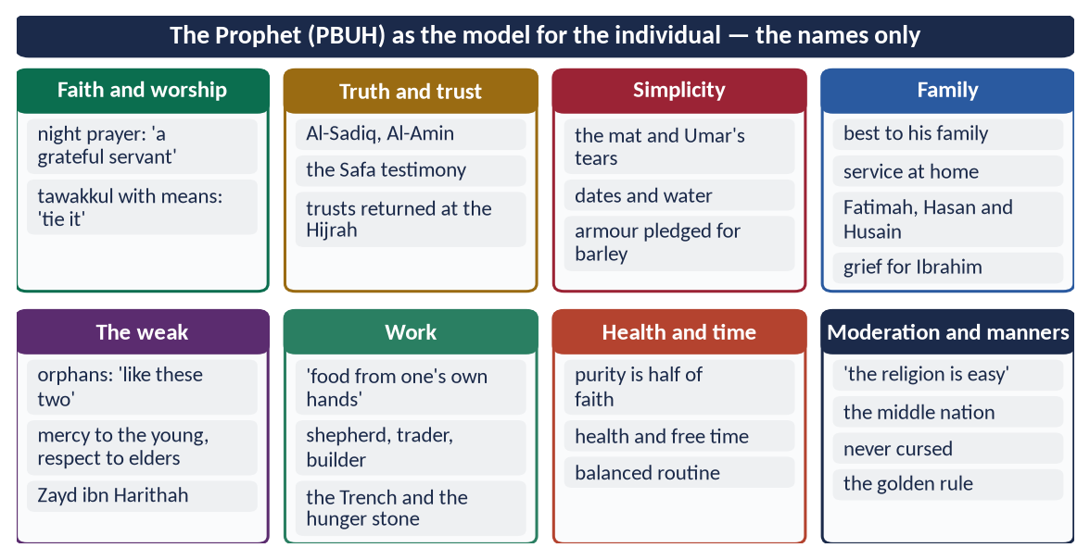
Figure 4 · At a glance — the Prophet ﷺ as the model for the individual — the names only. The detail is in the sections above.
PAKISTAN · THE INDIVIDUAL MODEL TODAY
The gap in Pakistan is not in love for the Prophet ﷺ but in following his individual model: truth in trade, punctuality, cleanliness of streets, honesty in exams and offices, kindness at home. A model answer should end with this gap — love proved by following (Aal-e-Imran: 'If you love Allah, follow me').

Chapter 3 · Makarim al-Akhlaq: Tolerance, Forgiveness and Noble Character
Asked as 'Tolerance and Forgiveness' (2020) and 'Makarim al-Akhlaq and social peace' (2025).

3.1 The meaning of Akhlaq and Makarim al-Akhlaq

(1) Akhlaq
Akhlaq (أَخْلَاق) is the plural of khuluq (خُلُق) — the inner nature from which actions come without effort. Imam al-Ghazali defines it as 'a settled state of the soul from which actions come easily, without thought'.

(2) Makarim al-Akhlaq
Makarim al-Akhlaq (مَكَارِمُ الْأَخْلَاق) are the noblest morals — not only avoiding harm, but doing good to those who harm you: forgiving the one who wrongs you, giving to the one who refuses you, joining the one who cuts you off.

3.2 Character as the purpose of the Prophethood
✦ QURAN
﴿وَإِنَّكَ لَعَلَىٰ خُلُقٍ عَظِيمٖ﴾
“And indeed, you are of a great moral character.” (Al-Qalam, Quran)
➜ 'You are of a great moral character' — the highest praise in the Quran for any person.

✦ HADITH
إِنَّمَا بُعِثْتُ لِأُتَمِّمَ مَكَارِمَ الْأَخْلَاقِ
“I was sent only to perfect the noblest morals.” (Al-Bayhaqi and Ahmad)
➜ The Prophet ﷺ described perfecting character as the aim of his mission.

✦ HADITH
إِنَّ مِنْ خِيَارِكُمْ أَحْسَنَكُمْ أَخْلَاقًا
“The best of you are those with the best character.” (Al-Bukhari)
➜ Character is the measure of rank.

✦ HADITH
أَكْمَلُ الْمُؤْمِنِينَ إِيمَانًا أَحْسَنُهُمْ خُلُقًا
“The most complete of the believers in faith is the best of them in character.” (Abu Dawud and Al-Tirmidhi)
➜ Faith and character are one scale.

✦ HADITH
مَا مِنْ شَيْءٍ أَثْقَلُ فِي الْمِيزَانِ مِنْ حُسْنِ الْخُلُقِ
“Nothing is heavier in the Scale than good character.” (Abu Dawud and Al-Tirmidhi)
➜ Character weighs most on the Day of Judgement.

3.3 How the Prophet ﷺ 'completed' the morals
The Arabs already prized some virtues — generosity, courage, hospitality, keeping one's word. The Prophet ﷺ did not reject them; he completed them in six ways.

(1) He gave them a new root — faith and accountability
Arab virtue was for tribal honour and fame; he made it for Allah and answerable on the Day of Judgement. Generosity for show became sadaqah for Allah's pleasure.
✦ QURAN
﴿إِنَّمَا نُطۡعِمُكُمۡ لِوَجۡهِ ٱللَّهِ لَا نُرِيدُ مِنكُمۡ جَزَآءٗ وَلَا شُكُورًا﴾
“[Saying], "We feed you only for the countenance of Allah. We wish not from you reward or gratitude.” (Al-Insan, Quran)
➜ 'We feed you only for the sake of Allah; we want from you no reward and no thanks.'

(2) He universalised them — from the tribe to humanity
Tribal ethics said 'help your brother, right or wrong'. He changed its meaning: 'Help your brother, whether he is the oppressor or the oppressed' — and helping the oppressor means stopping him from oppression (Al-Bukhari).
✦ QURAN
﴿يَـٰٓأَيُّهَا ٱلنَّاسُ إِنَّا خَلَقۡنَٰكُم مِّن ذَكَرٖ وَأُنثَىٰ وَجَعَلۡنَٰكُمۡ شُعُوبٗا وَقَبَآئِلَ لِتَعَارَفُوٓاْۚ إِنَّ أَكۡرَمَكُمۡ عِندَ ٱللَّهِ أَتۡقَىٰكُمۡۚ إِنَّ ٱللَّهَ عَلِيمٌ خَبِيرٞ﴾
“O mankind, indeed We have created you from male and female and made you peoples and tribes that you may know one another. Indeed, the most noble of you in the sight of Allah is the most righteous of you. Indeed, Allah is Knowing and Acquainted.” (Al-Hujurat, Quran)
➜ Honour is by taqwa, not by tribe or colour.

(3) He extended them to enemies
Justice even to those one hates:
✦ QURAN
﴿… وَلَا يَجۡرِمَنَّكُمۡ شَنَـَٔانُ قَوۡمٍ عَلَىٰٓ أَلَّا تَعۡدِلُواْۚ ٱعۡدِلُواْ هُوَ أَقۡرَبُ لِلتَّقۡوَىٰۖ …﴾
“Do not let the hatred of a people lead you to be unjust. Be just; that is nearer to righteousness.” (Al-Ma'idah, Quran)
➜ Hatred of a people must not lead to injustice — justice is nearer to taqwa.

(4) He balanced them
Courage without cruelty, generosity without waste, humility without weakness, mercy without injustice — the middle way (Al-Baqarah: 'a middle nation').

(5) He demonstrated them — the Quran in practice
He did not preach mercy and practise revenge. Every virtue he taught, he lived first (Chapter 1: 'his character was the Quran').

(6) He built them into institutions
Brotherhood (Mu'akhat), Zakat, the Charter of Madinah, the rights of neighbours, slaves, women and orphans — morals became law and society, not only private virtue.
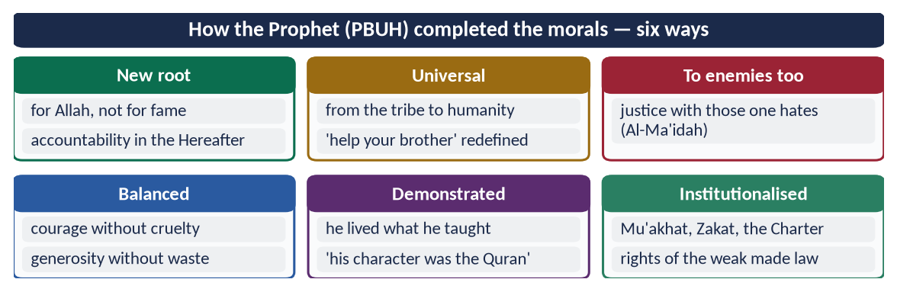
Figure 5 · At a glance — how the Prophet ﷺ completed the morals — six ways. The detail is in the sections above.

3.4 Tolerance and forgiveness — the status in his life

(1) The Quranic command to him
✦ QURAN
﴿خُذِ ٱلۡعَفۡوَ وَأۡمُرۡ بِٱلۡعُرۡفِ وَأَعۡرِضۡ عَنِ ٱلۡجَٰهِلِينَ﴾
“Take what is given freely, enjoin what is good, and turn away from the ignorant.” (Al-A'raf, Quran)
➜ 'Take to forgiveness, enjoin what is good, and turn away from the ignorant.'

✦ QURAN
﴿فَبِمَا رَحۡمَةٖ مِّنَ ٱللَّهِ لِنتَ لَهُمۡۖ وَلَوۡ كُنتَ فَظًّا غَلِيظَ ٱلۡقَلۡبِ لَٱنفَضُّواْ مِنۡ حَوۡلِكَۖ …﴾
“So by mercy from Allah you were gentle with them; had you been harsh and hard-hearted, they would have scattered from around you.” (Aal-e-Imran, Quran)
➜ His gentleness is a mercy from Allah; harshness would have scattered the people.

✦ QURAN
﴿وَلَا تَسۡتَوِي ٱلۡحَسَنَةُ وَلَا ٱلسَّيِّئَةُۚ ٱدۡفَعۡ بِٱلَّتِي هِيَ أَحۡسَنُ فَإِذَا ٱلَّذِي بَيۡنَكَ وَبَيۡنَهُۥ عَدَٰوَةٞ كَأَنَّهُۥ وَلِيٌّ حَمِيمٞ﴾
“And not equal are the good deed and the bad. Repel [evil] by that [deed] which is better; and thereupon the one whom between you and him is enmity [will become] as though he was a devoted friend.” (Fussilat, Quran)
➜ 'Repel evil with what is better' — then your enemy becomes a close friend.

(2) The grades of tolerance — lowest to highest
Grade | Arabic | Meaning and example
Sabr — patience | صَبْر | Bearing harm without complaint — the Makkan years.
Kazm al-ghayz — restraining anger | كَظْمُ الْغَيْظ | Holding anger inside (Aal-e-Imran 134).
Hilm — forbearance | حِلْم | Not reacting even when one has power — the Bedouin in the mosque.
'Afw — pardon | عَفْو | Cancelling the punishment one could take — the woman who poisoned him.
Safh — overlooking | صَفْح | Wiping the wrong from the heart — Wahshi, Hind, Ikrimah.
Ihsan — doing good in return | إِحْسَان | Rewarding harm with good — du'a for the people of Taif.

✦ QURAN
﴿ٱلَّذِينَ يُنفِقُونَ فِي ٱلسَّرَّآءِ وَٱلضَّرَّآءِ وَٱلۡكَٰظِمِينَ ٱلۡغَيۡظَ وَٱلۡعَافِينَ عَنِ ٱلنَّاسِۗ وَٱللَّهُ يُحِبُّ ٱلۡمُحۡسِنِينَ﴾
“Who spend [in the cause of Allah] during ease and hardship and who restrain anger and who pardon the people - and Allah loves the doers of good.” (Aal-e-Imran, Quran)
➜ Those who restrain anger and pardon people — Allah loves the doers of good (the grades in one verse).

(3) He never took revenge for himself
✦ HADITH
مَا انْتَقَمَ لِنَفْسِهِ فِي شَيْءٍ قَطُّ، إِلَّا أَنْ تُنْتَهَكَ حُرْمَةُ اللَّهِ
“He never took revenge for himself in anything — unless the sanctity of Allah was violated.” (Al-Bukhari and Muslim)
➜ Hazrat Aishah (RA): personal wrongs were forgiven; only Allah's law was enforced.

3.5 Tolerance and forgiveness — the great examples

(1) Taif (10th year of Prophethood)
Stoned until his shoes filled with blood, he was offered by the Angel of the Mountains the destruction of the town. He refused:
✦ HADITH
بَلْ أَرْجُو أَنْ يُخْرِجَ اللَّهُ مِنْ أَصْلَابِهِمْ مَنْ يَعْبُدُ اللَّهَ وَحْدَهُ لَا يُشْرِكُ بِهِ شَيْئًا
“Rather, I hope that Allah will bring from their descendants people who will worship Allah alone.” (Al-Bukhari and Muslim)
➜ At his lowest moment he chose hope over revenge — the highest grade, Ihsan.

(2) 'I was not sent to curse'
✦ HADITH
إِنِّي لَمْ أُبْعَثْ لَعَّانًا، وَإِنَّمَا بُعِثْتُ رَحْمَةً
“I was not sent as one who curses; I was sent only as a mercy.” (Muslim)
➜ Asked to curse the idolaters, he refused.

(3) The Conquest of Makkah (8 AH) — the general amnesty
Standing at the Ka'bah before the people who had persecuted him for twenty years, killed his Companions and driven him out, he asked: 'What do you think I will do to you?' They said: 'Good — a noble brother, son of a noble brother.' He said:
✦ QURAN
﴿قَالَ لَا تَثۡرِيبَ عَلَيۡكُمُ ٱلۡيَوۡمَۖ يَغۡفِرُ ٱللَّهُ لَكُمۡۖ وَهُوَ أَرۡحَمُ ٱلرَّـٰحِمِينَ﴾
“He said, "No blame will there be upon you today. Allah will forgive you; and He is the most merciful of the merciful.” (Yusuf, Quran)
➜ 'No blame upon you today' — the words of Prophet Yusuf to his brothers, repeated by the Prophet ﷺ to the Quraysh.

✦ FROM THE SIRAH
اذْهَبُوا فَأَنْتُمُ الطُّلَقَاءُ
“Go, you are all free.” (Sirat Ibn Hisham)
➜ A general amnesty — perhaps the greatest act of forgiveness in history.

He forgave Hind (who chewed the liver of his uncle Hamzah), Wahshi (who killed Hamzah), Ikrimah ibn Abi Jahl, Safwan ibn Umayyah and Habbar ibn al-Aswad (who had caused the death of his daughter Zaynab).

(4) The woman who poisoned him (Khaybar, 7 AH)
A woman of Khaybar served him poisoned meat. The Companions asked: 'Shall we kill her?' He said: 'No' (Al-Bukhari and Muslim) — personal pardon of an attempted murder.

(5) The Bedouin who urinated in the mosque
✦ HADITH
دَعُوهُ ... فَإِنَّمَا بُعِثْتُمْ مُيَسِّرِينَ، وَلَمْ تُبْعَثُوا مُعَسِّرِينَ
“Leave him … You were sent to make things easy, not to make them hard.” (Al-Bukhari)
➜ He stopped the Companions, had water poured, and taught the man gently.

(6) The Bedouin who pulled his cloak
A Bedouin pulled his cloak so hard that it marked his neck and demanded, 'Give me from Allah's wealth!' He turned, smiled, and ordered that he be given (Al-Bukhari and Muslim).

(7) Gentleness in the face of insult
Some men greeted him with 'as-samu 'alaykum' (death be upon you). Hazrat Aishah (RA) replied angrily; he said:
✦ HADITH
مَهْلًا يَا عَائِشَةُ، إِنَّ اللَّهَ يُحِبُّ الرِّفْقَ فِي الْأَمْرِ كُلِّهِ
“Gently, O Aishah; Allah loves gentleness in every matter.” (Al-Bukhari and Muslim)
➜ Even insult was answered with dignity.

(8) Abdullah ibn Ubayy — the leader of the hypocrites
Who spread the slander against Hazrat Aishah (RA) and withdrew a third of the army at Uhud; yet the Prophet ﷺ gave his shirt for his shroud and led his funeral prayer (Al-Bukhari).
TRAP · THE OLD WOMAN AND THE RUBBISH
The popular story of an old woman who threw rubbish on the Prophet ﷺ every day, and whom he visited when she fell ill, has no authentic source. Examiners who know the Sirah notice it. Use Taif, the Conquest of Makkah, the poisoning at Khaybar and the Bedouin — all in Al-Bukhari and Muslim.

3.6 Religious tolerance with non-Muslims

(1) The Quranic principles
✦ QURAN
﴿لَآ إِكۡرَاهَ فِي ٱلدِّينِۖ قَد تَّبَيَّنَ ٱلرُّشۡدُ مِنَ ٱلۡغَيِّۚ …﴾
“There is no compulsion in religion; the right course has become clear from the wrong.” (Al-Baqarah, Quran)
➜ No compulsion in religion — faith cannot be forced.

✦ QURAN
﴿لَكُمۡ دِينُكُمۡ وَلِيَ دِينِ﴾
“For you is your religion, and for me is my religion.” (Al-Kafirun, Quran)
➜ 'For you your religion, and for me mine' — coexistence without compromise of belief.

✦ QURAN
﴿لَّا يَنۡهَىٰكُمُ ٱللَّهُ عَنِ ٱلَّذِينَ لَمۡ يُقَٰتِلُوكُمۡ فِي ٱلدِّينِ وَلَمۡ يُخۡرِجُوكُم مِّن دِيَٰرِكُمۡ أَن تَبَرُّوهُمۡ وَتُقۡسِطُوٓاْ إِلَيۡهِمۡۚ إِنَّ ٱللَّهَ يُحِبُّ ٱلۡمُقۡسِطِينَ﴾
“Allah does not forbid you from those who do not fight you because of religion and do not expel you from your homes - from being righteous toward them and acting justly toward them. Indeed, Allah loves those who act justly.” (Al-Mumtahanah, Quran)
➜ Allah does not forbid kindness and justice to non-Muslims who do not fight you.

(2) The practice
- (a) Respect for the human being: he stood for a Jewish funeral.
✦ HADITH
أَلَيْسَتْ نَفْسًا
“Is it not a human soul?” (Al-Bukhari and Muslim)
➜ Human dignity is not limited to believers.

- (b) The Christians of Najran were lodged in the Mosque of Madinah and allowed to pray there in their own way (Ibn Ishaq; Ibn al-Qayyim, Zad al-Ma'ad).
- (c) Protection of non-Muslim citizens:
✦ HADITH
مَنْ قَتَلَ مُعَاهَدًا لَمْ يَرِحْ رَائِحَةَ الْجَنَّةِ
“Whoever kills a non-Muslim living under a covenant will not smell the fragrance of Paradise.” (Al-Bukhari)
➜ The mu'ahad (مُعَاهَد) is under the Prophet's ﷺ protection.

- (d) Dealings: he visited a sick Jewish boy, traded with Jews, and died with his armour pledged to one.

3.7 From noble morals to social peace (the 2025 link)
Makarim al-Akhlaq are the foundation of social peace because law can punish crime but cannot create trust; only character can.
Moral | How it produces social peace
Truthfulness (صِدْق) | Trust in trade, courts and government; no fraud.
Trustworthiness (أَمَانَة) | Safe property, honest officials, fulfilled contracts.
Justice (عَدْل) | No sense of grievance; no one takes the law into his own hands.
Forgiveness (عَفْو) | Ends cycles of revenge and blood feud.
Mercy (رَحْمَة) | Care for the weak; no class hatred.
Modesty (حَيَاء) | Protects the family and public decency.
Brotherhood (أُخُوَّة) | Unity across tribe, race and class.
Controlling the tongue | No slander, backbiting or rumour — the causes of social conflict.

✦ QURAN
﴿… ٱجۡتَنِبُواْ كَثِيرٗا مِّنَ ٱلظَّنِّ إِنَّ بَعۡضَ ٱلظَّنِّ إِثۡمٞۖ وَلَا تَجَسَّسُواْ وَلَا يَغۡتَب بَّعۡضُكُم بَعۡضًاۚ …﴾
“Avoid much suspicion; indeed, some suspicion is sin. And do not spy, and do not backbite one another.” (Al-Hujurat, Quran)
➜ Avoid suspicion, spying and backbiting — the Quran removes the causes of social quarrel.

✦ HADITH
لَيْسَ الشَّدِيدُ بِالصُّرَعَةِ، إِنَّمَا الشَّدِيدُ الَّذِي يَمْلِكُ نَفْسَهُ عِنْدَ الْغَضَبِ
“The strong man is not the wrestler; the strong man is the one who controls himself when angry.” (Al-Bukhari and Muslim)
➜ Anger control prevents most social violence.

✦ HADITH
أَلَا أُخْبِرُكُمْ بِأَفْضَلَ مِنْ دَرَجَةِ الصِّيَامِ وَالصَّلَاةِ وَالصَّدَقَةِ؟ ... صَلَاحُ ذَاتِ الْبَيْنِ
“Shall I not tell you of something better in rank than fasting, prayer and charity? … Reconciling between people.” (Abu Dawud and Al-Tirmidhi)
➜ Making peace between people is ranked above voluntary worship.

The proof in history
The Arabs before Islam lived in blood feuds — the war of Basus lasted about forty years, and Bu'ath (617) had just exhausted Yathrib. Within twenty-three years the same people became brothers:
✦ QURAN
﴿وَٱعۡتَصِمُواْ بِحَبۡلِ ٱللَّهِ جَمِيعٗا وَلَا تَفَرَّقُواْۚ وَٱذۡكُرُواْ نِعۡمَتَ ٱللَّهِ عَلَيۡكُمۡ إِذۡ كُنتُمۡ أَعۡدَآءٗ فَأَلَّفَ بَيۡنَ قُلُوبِكُمۡ فَأَصۡبَحۡتُم بِنِعۡمَتِهِۦٓ إِخۡوَٰنٗا …﴾
“And hold firmly to the rope of Allah all together and do not become divided. Remember Allah's favour upon you: you were enemies, and He brought your hearts together, and by His favour you became brothers.” (Aal-e-Imran, Quran)
➜ 'You were enemies and He brought your hearts together and you became brothers by His favour.'

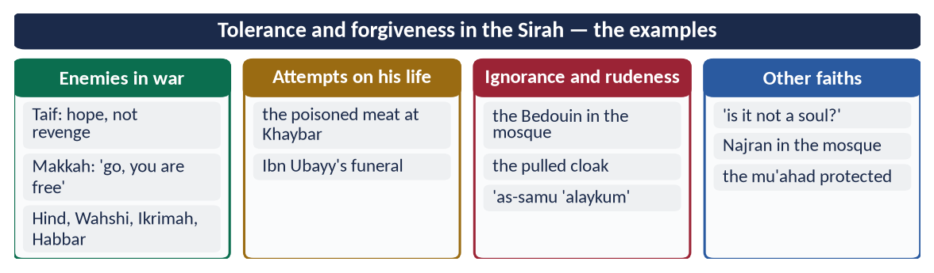
Figure 6 · At a glance — tolerance and forgiveness in the Sirah — the examples. The detail is in the sections above.

Chapter 4 · The Prophet ﷺ as Educator
Named in the syllabus, never asked yet — the most likely surprise of this topic.

4.1 The first word of revelation was about knowledge
✦ QURAN
﴿ٱقۡرَأۡ بِٱسۡمِ رَبِّكَ ٱلَّذِي خَلَقَ ۝ خَلَقَ ٱلۡإِنسَٰنَ مِنۡ عَلَقٍ ۝ ٱقۡرَأۡ وَرَبُّكَ ٱلۡأَكۡرَمُ ۝ ٱلَّذِي عَلَّمَ بِٱلۡقَلَمِ ۝ عَلَّمَ ٱلۡإِنسَٰنَ مَا لَمۡ يَعۡلَمۡ﴾
“Recite in the name of your Lord who created. Created man from a clinging substance. Recite, and your Lord is the most Generous. Who taught by the pen. Taught man that which he knew not.” (Al-Alaq, Quran)
➜ 'Read in the name of your Lord who created … who taught by the pen, taught man what he did not know' — the message began with reading and the pen.

✦ QURAN
﴿… وَقُل رَّبِّ زِدۡنِي عِلۡمٗا﴾
“And say: 'My Lord, increase me in knowledge.'” (Taha, Quran)
➜ The Prophet ﷺ was taught to pray: 'My Lord, increase me in knowledge' — the only thing he was told to ask more of.

4.2 Teaching as the purpose of his mission

(1) The four functions — the key verse
✦ QURAN
﴿هُوَ ٱلَّذِي بَعَثَ فِي ٱلۡأُمِّيِّـۧنَ رَسُولٗا مِّنۡهُمۡ يَتۡلُواْ عَلَيۡهِمۡ ءَايَٰتِهِۦ وَيُزَكِّيهِمۡ وَيُعَلِّمُهُمُ ٱلۡكِتَٰبَ وَٱلۡحِكۡمَةَ وَإِن كَانُواْ مِن قَبۡلُ لَفِي ضَلَٰلٖ مُّبِينٖ﴾
“It is He who has sent among the unlettered a Messenger from themselves reciting to them His verses and purifying them and teaching them the Book and wisdom - although they were before in clear error.” (Al-Jumu'ah, Quran)
➜ Allah sent among the unlettered a Messenger who recites His verses, purifies them, and teaches the Book and wisdom.

Function | Arabic | What it means for education
Tilawah — reciting | تِلَاوَة | Conveying the text: the curriculum.
Tazkiyah — purifying | تَزْكِيَة | Moral training: character before information.
Ta'lim al-Kitab — teaching the Book | تَعْلِيمُ الْكِتَاب | Explaining its meaning and law.
Ta'lim al-Hikmah — teaching wisdom | تَعْلِيمُ الْحِكْمَة | Applying knowledge to life: judgement and understanding.

The same four appear in the prayer of Ibrahim (Al-Baqarah 129), in Al-Baqarah 151 and in Aal-e-Imran 164 — four times the Quran defines his mission as education.

(2) In his own words: 'sent as a teacher'
✦ HADITH
إِنَّ اللَّهَ لَمْ يَبْعَثْنِي مُعَنِّتًا وَلَا مُتَعَنِّتًا، وَلَكِنْ بَعَثَنِي مُعَلِّمًا مُيَسِّرًا
“Allah did not send me to be harsh or to cause hardship; He sent me as a teacher who makes things easy.” (Muslim)
➜ He named himself a mu'allim (مُعَلِّم) — a teacher.

(3) Knowledge made a duty for all
✦ QURAN
﴿… قُلۡ هَلۡ يَسۡتَوِي ٱلَّذِينَ يَعۡلَمُونَ وَٱلَّذِينَ لَا يَعۡلَمُونَۗ …﴾
“Say: are those who know equal to those who do not know?” (Az-Zumar, Quran)
➜ 'Are those who know equal to those who do not know?'

✦ QURAN
﴿… يَرۡفَعِ ٱللَّهُ ٱلَّذِينَ ءَامَنُواْ مِنكُمۡ وَٱلَّذِينَ أُوتُواْ ٱلۡعِلۡمَ دَرَجَٰتٖۚ …﴾
“Allah will raise those who have believed among you and those who were given knowledge, by degrees.” (Al-Mujadilah, Quran)
➜ Allah raises by degrees those who believe and those given knowledge.

✦ HADITH
طَلَبُ الْعِلْمِ فَرِيضَةٌ عَلَى كُلِّ مُسْلِمٍ
“Seeking knowledge is an obligation upon every Muslim.” (Ibn Majah)
➜ Education is universal — for men and women, rich and poor.

4.3 The institutions he built

(1) Dar al-Arqam — the first school (Makkah)
In the house of Arqam ibn Abi al-Arqam (RA) on Safa, the first believers were taught in secret — the first centre of Islamic learning.

(2) Mus'ab ibn Umair — the first teacher sent abroad
After the first pledge of Aqabah (621), he sent Mus'ab ibn Umair (RA) to Yathrib as a teacher; within a year almost every family of the Ansar had a Muslim — education prepared the Hijrah.

(3) The Mosque of Madinah and Suffah — the first residential university
The Suffah (صُفَّة), a shaded platform in the Mosque, housed poor students — at times about seventy or more. Abu Hurairah (RA), the greatest narrator of Hadith, was its student. The Mosque itself was classroom, court and parliament.

(4) Literacy through prisoners of war (Badr, 2 AH)
Literate prisoners of Badr who could not pay ransom were freed on condition that each taught ten Muslim children to read and write (Ibn Sa'd; Ahmad). A prisoner of war became a teacher — unique in the history of war.

(5) Scribes and languages
He had over forty scribes (katibs) for revelation, letters and treaties. He told Zayd ibn Thabit (RA) to learn the script of the Jews; Zayd learned it in about half a month (Al-Tirmidhi; Al-Bukhari) — foreign languages for the state's needs.

(6) Teachers sent across Arabia
Mu'adh ibn Jabal and Abu Musa al-Ash'ari (RA) to Yemen; teachers with every delegation. At Bi'r Ma'unah seventy reciters were martyred on a teaching mission — education carried at the cost of life.

4.4 His methods of teaching

(1) Gentleness — the best teacher anyone saw
✦ HADITH
فَبِأَبِي هُوَ وَأُمِّي، مَا رَأَيْتُ مُعَلِّمًا قَبْلَهُ وَلَا بَعْدَهُ أَحْسَنَ تَعْلِيمًا مِنْهُ
“May my father and mother be his ransom — I never saw a teacher before him or after him who taught better than he did.” (Muslim)
➜ Mu'awiyah ibn al-Hakam (RA) spoke in prayer by mistake; the Prophet ﷺ did not scold or beat him but explained kindly.

(2) Making things easy
✦ HADITH
يَسِّرُوا وَلَا تُعَسِّرُوا، وَبَشِّرُوا وَلَا تُنَفِّرُوا
“Make things easy and do not make them difficult; give good news and do not drive people away.” (Al-Bukhari and Muslim)
➜ The first rule of teaching: no fear, no burden.

(3) Questions to awaken the mind
✦ HADITH
أَتَدْرُونَ مَا الْمُفْلِسُ؟
“Do you know who the bankrupt is?” (Muslim)
➜ He started with a question, took their answer ('one with no money'), then gave the deeper meaning — the one who comes with prayers but had wronged people.

(4) Repetition for clarity
✦ HADITH
كَانَ إِذَا تَكَلَّمَ بِكَلِمَةٍ أَعَادَهَا ثَلَاثًا حَتَّى تُفْهَمَ عَنْهُ
“When he said something important he repeated it three times so that it would be understood.” (Al-Bukhari)
➜ Repetition fixes learning.

(5) Practical demonstration
✦ HADITH
صَلُّوا كَمَا رَأَيْتُمُونِي أُصَلِّي
“Pray as you have seen me pray.” (Al-Bukhari)
➜ Learning by seeing and doing, not only hearing.

(6) Drawings and examples
He drew a straight line and lines branching from it — 'this is the path of Allah, and these are paths with a devil on each' — then recited Al-An'am 153 (Ahmad). He drew a square to show man, his hopes and his death (Al-Bukhari). Parables — the palm tree like the believer, the two men on a ship — made abstract ideas concrete.

(7) Gradualism
✦ HADITH
فَادْعُهُمْ إِلَى شَهَادَةِ أَنْ لَا إِلَهَ إِلَّا اللَّهُ ... فَإِنْ هُمْ أَطَاعُوا لِذَلِكَ فَأَعْلِمْهُمْ أَنَّ اللَّهَ افْتَرَضَ عَلَيْهِمْ خَمْسَ صَلَوَاتٍ
“Invite them first to the testimony that there is no god but Allah … if they accept it, teach them that Allah has made five prayers obligatory …” (Al-Bukhari and Muslim)
➜ His instruction to Mu'adh (RA) for Yemen: teach step by step, from the root to the branches.

(8) Spacing the lessons to avoid boredom
✦ HADITH
كَانَ النَّبِيُّ ﷺ يَتَخَوَّلُنَا بِالْمَوْعِظَةِ فِي الْأَيَّامِ كَرَاهَةَ السَّآمَةِ عَلَيْنَا
“The Prophet ﷺ used to space out his advice to us over days, disliking that we become bored.” (Al-Bukhari)
➜ Ibn Mas'ud (RA) — short, spaced lessons.

(9) Attention to individual differences
Asked 'which deed is best?', he answered differently to different people — prayer on time, kindness to parents, jihad, feeding others — according to each one's need.

(10) Encouraging questions and involving women
He welcomed questions; when women asked for their own time, he gave them a separate day for teaching (Al-Bukhari). Hazrat Aishah (RA) praised the women of the Ansar whose modesty did not stop them from learning.

(11) Teaching by character — the teacher as example
He did what he taught. A teacher whose practice contradicts his lesson teaches nothing (As-Saff: 'why do you say what you do not do?').

(12) Every learner a teacher
✦ HADITH
بَلِّغُوا عَنِّي وَلَوْ آيَةً
“Convey from me, even if it is one verse.” (Al-Bukhari)
➜ He made the whole Ummah a chain of teachers.

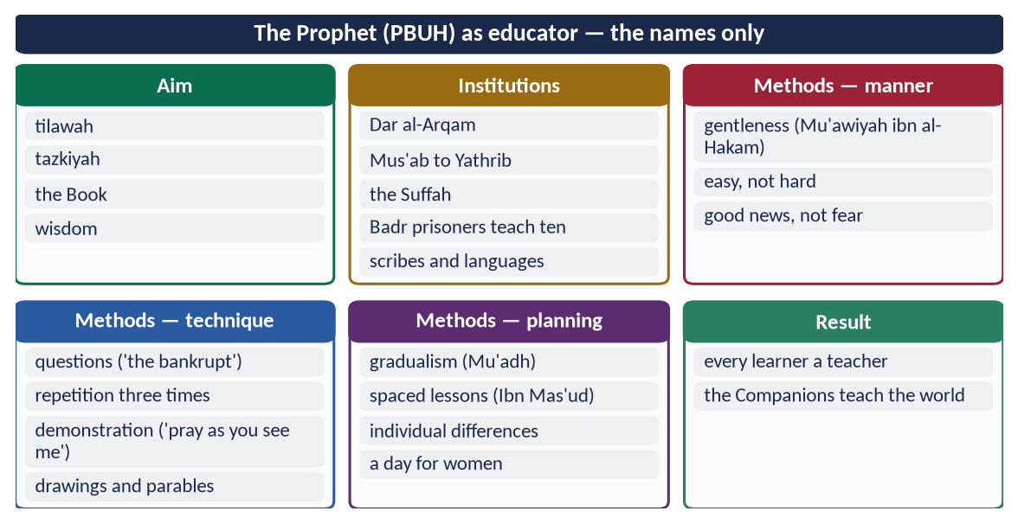
Figure 7 · At a glance — the Prophet ﷺ as educator — the names only. The detail is in the sections above.

4.5 The result — a generation of teachers
In twenty-three years, an unlettered people produced the teachers of the world: Ibn Abbas (the interpreter of the Quran), Ibn Mas'ud (founder of the school of Kufa, from which Imam Abu Hanifah's fiqh grew), Zayd ibn Thabit (compiler of the Quran), Hazrat Aishah (a teacher of the senior Companions), Mu'adh ibn Jabal (the most learned in halal and haram).
✦ SCHOLARLY VIEW
Syed Sulaiman Nadvi · Sirat-un-Nabi
Nadvi describes the Suffah as the first residential university of Islam and the Companions as its graduates, who carried the Prophet's ﷺ teaching from Madinah to Spain and China within a century.
➜ Education was the engine of the Islamic civilisation.

PAKISTAN · THE EDUCATOR MODEL TODAY
About 26 million children are out of school in Pakistan and the literacy rate is about 60 percent. The Prophetic model answers: education as a duty (Article 25-A: free and compulsory education for ages 5–16), character with information (tazkiyah), gentle teaching instead of corporal punishment, women's education, and a single chain in which every learner teaches.

Chapter 5 · The Prophet ﷺ as Diplomat
Also never asked yet — its evidence overlaps with the peace chapters, so it costs little to prepare.

5.1 The meaning of diplomacy and its Quranic basis
Diplomacy is the conduct of relations between states or communities by negotiation, envoys and treaties, in order to secure interests without war. The Quran sets its principles:
✦ QURAN
﴿ٱدۡعُ إِلَىٰ سَبِيلِ رَبِّكَ بِٱلۡحِكۡمَةِ وَٱلۡمَوۡعِظَةِ ٱلۡحَسَنَةِۖ وَجَٰدِلۡهُم بِٱلَّتِي هِيَ أَحۡسَنُۚ …﴾
“Invite to the way of your Lord with wisdom and good instruction, and argue with them in the way that is best.” (An-Nahl, Quran)
➜ Invite with wisdom and good instruction, and argue in the best way — the manner of every letter and envoy.

✦ QURAN
﴿وَإِن جَنَحُواْ لِلسَّلۡمِ فَٱجۡنَحۡ لَهَا وَتَوَكَّلۡ عَلَى ٱللَّهِۚ إِنَّهُۥ هُوَ ٱلسَّمِيعُ ٱلۡعَلِيمُ﴾
“And if they incline to peace, then incline to it [also] and rely upon Allah. Indeed, it is He who is the Hearing, the Knowing.” (Al-Anfal, Quran)
➜ 'If they incline to peace, incline to it' — diplomacy is preferred to war.

✦ QURAN
﴿… وَأَوۡفُواْ بِٱلۡعَهۡدِۖ إِنَّ ٱلۡعَهۡدَ كَانَ مَسۡـُٔولٗا﴾
“And fulfil every commitment; indeed, the commitment will be questioned about.” (Al-Isra, Quran)
➜ 'Fulfil every commitment' — a treaty is a trust.

✦ QURAN
﴿قُلۡ يَـٰٓأَهۡلَ ٱلۡكِتَٰبِ تَعَالَوۡاْ إِلَىٰ كَلِمَةٖ سَوَآءِۭ بَيۡنَنَا وَبَيۡنَكُمۡ أَلَّا نَعۡبُدَ إِلَّا ٱللَّهَ وَلَا نُشۡرِكَ بِهِۦ شَيۡـٔٗا وَلَا يَتَّخِذَ بَعۡضُنَا بَعۡضًا أَرۡبَابٗا مِّن دُونِ ٱللَّهِۚ …﴾
“Say: O People of the Scripture, come to a word common between us and you: that we worship none but Allah, associate nothing with Him, and that none of us take others as lords besides Allah.” (Aal-e-Imran, Quran)
➜ 'Come to a word common between us and you' — the method of dialogue with other faiths; the very verse he wrote to Heraclius.

5.2 Diplomatic skill before Prophethood

(1) Hilf al-Fudul — the League of the Virtuous
As a young man he joined the pact, in the house of Abdullah ibn Jud'an, by which the clans of Makkah swore to protect anyone wronged in the city.
✦ FROM THE SIRAH
لَقَدْ شَهِدْتُ فِي دَارِ عَبْدِ اللَّهِ بْنِ جُدْعَانَ حِلْفًا مَا أُحِبُّ أَنَّ لِي بِهِ حُمْرَ النَّعَمِ، وَلَوْ أُدْعَى بِهِ فِي الْإِسْلَامِ لَأَجَبْتُ
“I witnessed a pact in the house of Abdullah ibn Jud'an that I would not exchange for the finest red camels; if I were invited to it in Islam, I would accept.” (Al-Bayhaqi; Sirat Ibn Hisham)
➜ He approved a pact with non-Muslims for justice — the basis of alliances for human rights.

(2) The Black Stone (605)
When the Quraysh were about to fight over who would place the Black Stone in the rebuilt Ka'bah, he spread his cloak, placed the Stone on it and had every clan's chief lift a corner — conflict resolution by giving every party a share of honour (Ibn Hisham).

5.3 Diplomacy of asylum — the Hijrah to Abyssinia (615)
He sent the persecuted Muslims to Najashi (Negus), 'a king in whose land no one is wronged'. When the Quraysh envoys demanded their return, Ja'far ibn Abi Talib (RA) presented Islam and recited Surah Maryam; the Negus refused to hand them over. The first political asylum in Islam — secured by choosing the right ally and the right spokesman.

5.4 Diplomacy in Madinah — agreements and alliances
- (a) The pledges of Aqabah (621, 622) — agreements with the Aws and Khazraj that made the Hijrah possible.
- (b) The Charter of Madinah (1 AH) — a written constitution among Muslims, Jews and tribes (Chapter 9).
- (c) Treaties with the coastal tribes — Banu Damrah (2 AH, the first treaty), Banu Mudlij, Juhaynah — securing the routes around Madinah.
- (d) The Treaty of Hudaybiyyah (6 AH) — his diplomatic masterpiece (Chapter 10).
- (e) Treaties of Tabuk (9 AH) with Aylah, Adhruh, Jarba and Dumat al-Jandal — securing the northern frontier without a battle.

5.5 The letters to the rulers (6–7 AH)
After Hudaybiyyah brought peace in Arabia, he wrote to the rulers around it. A silver ring was made as a seal, because kings accepted only sealed letters (Al-Bukhari); it read 'Muhammad Rasul Allah' (مُحَمَّدٌ رَسُولُ اللَّه).
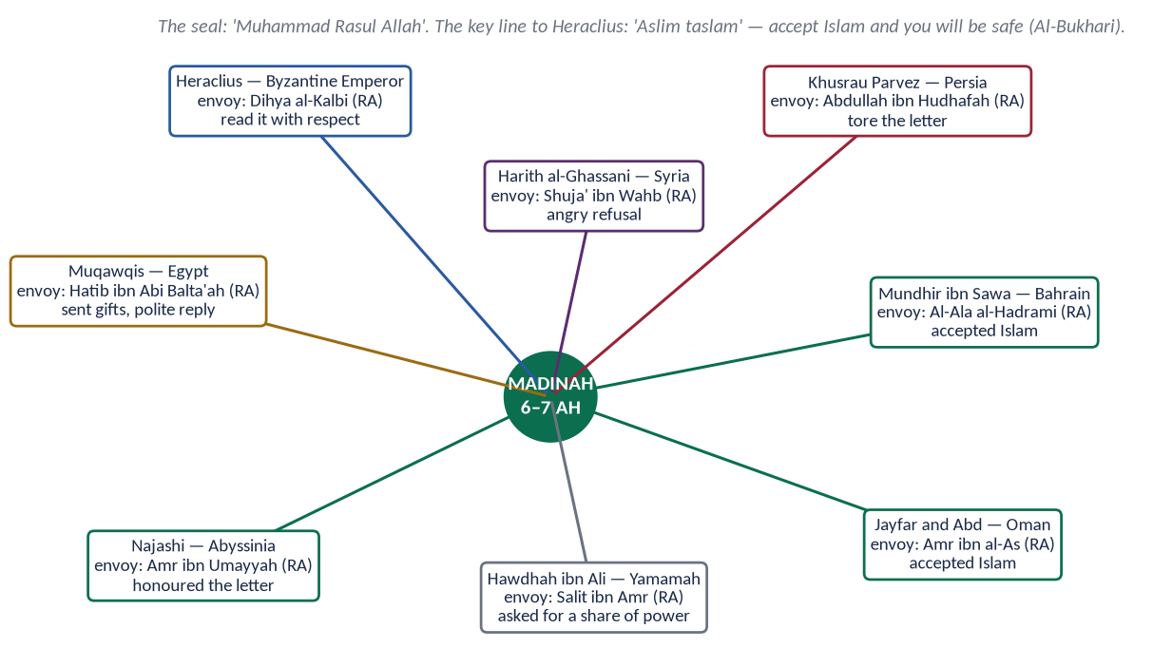
Figure 8 · The letters to the rulers, their envoys and the replies.

(1) The letter to Heraclius — the model text
✦ FROM THE SIRAH
بِسْمِ اللَّهِ الرَّحْمَنِ الرَّحِيمِ، مِنْ مُحَمَّدٍ عَبْدِ اللَّهِ وَرَسُولِهِ إِلَى هِرَقْلَ عَظِيمِ الرُّومِ، سَلَامٌ عَلَى مَنِ اتَّبَعَ الْهُدَى، أَمَّا بَعْدُ فَإِنِّي أَدْعُوكَ بِدِعَايَةِ الْإِسْلَامِ، أَسْلِمْ تَسْلَمْ، يُؤْتِكَ اللَّهُ أَجْرَكَ مَرَّتَيْنِ
“In the name of Allah, the Most Gracious, the Most Merciful. From Muhammad, the servant of Allah and His Messenger, to Heraclius, the great one of the Romans. Peace be upon whoever follows guidance. I invite you with the call of Islam: accept Islam and you will be safe, and Allah will give you your reward twice …” (Al-Bukhari)
➜ Short, respectful ('the great one of the Romans'), clear, and ending with Aal-e-Imran 64, the common word.

Heraclius questioned Abu Sufyan, then an enemy, about the Prophet ﷺ — his lineage, his honesty, his followers — and concluded that he was a true prophet, though he did not accept Islam for fear of his court (Al-Bukhari).

(2) The features of the letters
Feature | Diplomatic meaning
Begins with Bismillah | His identity is stated openly — no hidden agenda.
Respectful titles | 'Great one of the Romans', 'great one of the Copts' — honour to the office.
Brevity and clarity | A few lines; the purpose is plain.
The right envoy | Dihya al-Kalbi, known for his fine looks and manners, to Heraclius; Amr ibn al-As, a skilled speaker, to Oman.
Peace offered | 'Aslim taslam' — safety through acceptance, not threats of war.
Responsibility of the ruler | 'If you turn away, you bear the sin of your subjects' — leaders answer for their people.
Sealed | Accepted protocol of the courts respected.

5.6 Envoys, delegations and immunity

(1) The immunity of envoys
✦ HADITH
لَوْلَا أَنَّ الرُّسُلَ لَا تُقْتَلُ لَضَرَبْتُ أَعْنَاقَكُمَا
“Were it not that envoys are not killed, I would have struck your necks.” (Abu Dawud)
➜ Said to the envoys of Musaylimah who declared their master a prophet — diplomatic immunity twelve centuries before the Vienna Convention (1961).

(2) The Year of Delegations (9 AH)
'Am al-Wufud (عَامُ الْوُفُود): over seventy delegations came from all over Arabia. He received them in the Mosque, gave them gifts and food, taught them, and sent teachers back with them. The Christians of Najran debated with him and made a treaty; Thaqif of Taif, who had stoned him, came and accepted Islam.

(3) Hospitality and gifts
He accepted the gifts of the Muqawqis and sent gifts to the Negus. He instructed at his death: 'Give gifts to delegations as I used to give them' (Al-Bukhari).

5.7 The principles of Prophetic diplomacy
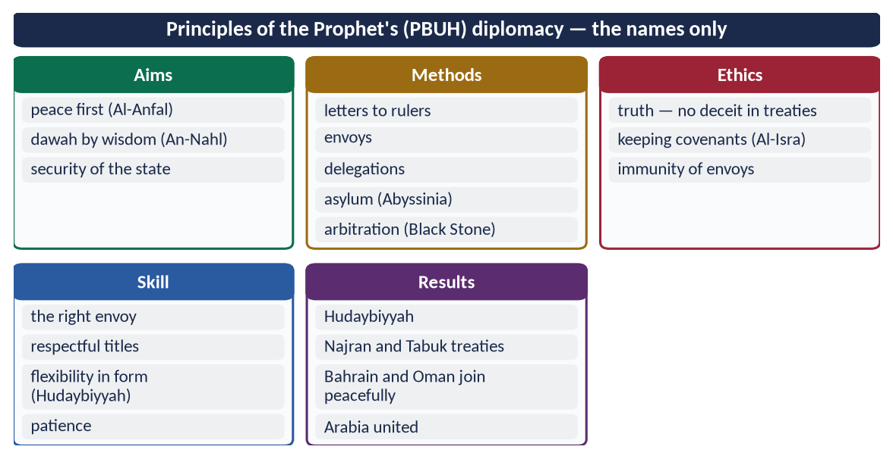
Figure 9 · At a glance — principles of the Prophet's ﷺ diplomacy — the names only. The detail is in the sections above.
✦ SCHOLARLY VIEW
Dr Muhammad Hamidullah · The First Written Constitution in the World; Muslim Conduct of State
Hamidullah, the Pakistani-born scholar of Islamic international law, showed that the Prophet's ﷺ letters, treaties and envoys laid down the rules of Islamic international law (siyar) — the respect of treaties, the immunity of envoys and the rights of non-combatants — long before modern international law.
➜ The scholar to quote on the diplomat and on the Charter.

EXAMINER'S EYE · IF 'DIPLOMAT' IS ASKED
Build it in five headings: (1) Quranic principles; (2) diplomacy before Prophethood — Hilf al-Fudul, Black Stone; (3) Abyssinia — asylum; (4) treaties — Charter, Hudaybiyyah, Tabuk; (5) letters, envoys and delegations — with the letters map. End with relevance to Pakistan's foreign policy: peace, dialogue, respect for treaties.

Chapter 6 · The Prophet ﷺ as Military Strategist
Asked three times: the characteristics of a military strategist (2016), his character in the battlefield as commander (2019), his role as a model for military strategy (2023).

6.1 The background — why a Prophet had to lead armies
For thirteen years in Makkah he and his Companions were forbidden to fight back, even under torture. After the Hijrah the Quraysh continued to threaten Madinah; the first permission to fight came only then:
✦ QURAN
﴿أُذِنَ لِلَّذِينَ يُقَٰتَلُونَ بِأَنَّهُمۡ ظُلِمُواْۚ وَإِنَّ ٱللَّهَ عَلَىٰ نَصۡرِهِمۡ لَقَدِيرٌ﴾
“Permission [to fight] has been given to those who are being fought, because they were wronged. And indeed, Allah is competent to give them victory.” (Al-Hajj, Quran)
➜ 'Permission is given to those who are fought against, because they have been wronged.'

He was now the head of a state; defending it was his duty. In ten years he led the Muslims through a complete military cycle — defence, deterrence, alliances, offence to end threats, and finally peace.

6.2 Ghazwat and Saraya — the numbers
Term | Meaning
Ghazwah (غَزْوَة) | An expedition he led in person — about 27, with actual fighting in about nine (Badr, Uhud, Khandaq, Banu Qurayzah, Banu al-Mustaliq, Khaybar, Makkah, Hunayn, Taif).
Sariyyah (سَرِيَّة) | An expedition he sent under a Companion — about 50–60.

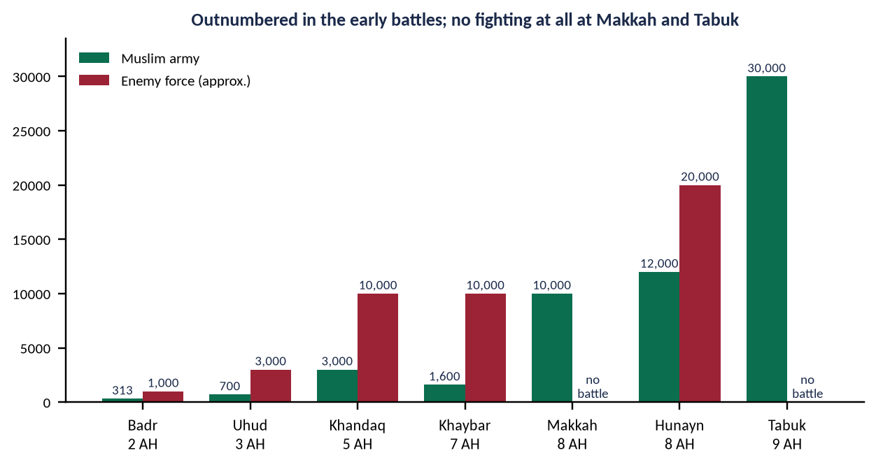
Figure 10 · The size of the Muslim army and the enemy in the major Ghazwat (approximate figures from the Sirah).
Ghazwah | Year | Muslims vs enemy | Strategic point
Badr | 2 AH | 313 vs about 1,000 | Choice of ground at the wells; night rest; rows (saff); consultation (Hubab ibn al-Mundhir)
Uhud | 3 AH | about 700 vs 3,000 | Mountain at the back; 50 archers on the hill; defeat when the order was broken
Khandaq | 5 AH | 3,000 vs about 10,000 | Trench (Salman al-Farisi); splitting the allies (Nu'aym ibn Mas'ud); intelligence (Hudhayfah)
Hudaybiyyah | 6 AH | 1,400 — no battle | Treaty instead of war
Khaybar | 7 AH | 1,600 vs about 10,000 | Fort-by-fort siege; cut off Ghatafan's help
Makkah | 8 AH | 10,000 — almost no battle | Secrecy; ten thousand fires; four columns; amnesty
Hunayn | 8 AH | 12,000 vs about 20,000 | Ambush in the valley; his steadfastness turned the retreat
Tabuk | 9 AH | 30,000 — no battle | Deterrence of Byzantium; treaties with border towns

6.3 The principles of his military strategy

(1) Preparation and deterrence
✦ QURAN
﴿وَأَعِدُّواْ لَهُم مَّا ٱسۡتَطَعۡتُم مِّن قُوَّةٖ وَمِن رِّبَاطِ ٱلۡخَيۡلِ تُرۡهِبُونَ بِهِۦ عَدُوَّ ٱللَّهِ وَعَدُوَّكُمۡ …﴾
“Prepare against them whatever you are able of power and of steeds of war, by which you may deter the enemy of Allah and your enemy.” (Al-Anfal, Quran)
➜ Prepare whatever strength you can — the aim is to deter the enemy (turhibuna), so that war does not happen.

He encouraged archery and horsemanship ('Power is in shooting', Muslim) and kept the army ready — deterrence, not aggression.

(2) Intelligence (information)
Before Badr he himself went out with Abu Bakr (RA) to gather information and asked two water-carriers how many camels the Quraysh slaughtered daily — 'nine or ten' — and judged their number at 900 to 1,000 (Ibn Hisham). At the Trench he sent Hudhayfah (RA) into the enemy camp at night.

(3) Consultation (Shura)
✦ QURAN
﴿فَبِمَا رَحۡمَةٖ مِّنَ ٱللَّهِ لِنتَ لَهُمۡۖ وَلَوۡ كُنتَ فَظًّا غَلِيظَ ٱلۡقَلۡبِ لَٱنفَضُّواْ مِنۡ حَوۡلِكَۖ …﴾
“So by mercy from Allah you were gentle with them; had you been harsh and hard-hearted, they would have scattered from around you.” (Aal-e-Imran, Quran)
➜ 'Consult them in the matter; and when you have decided, rely upon Allah.'

- At Badr, Hubab ibn al-Mundhir (RA) asked, 'Is this position revelation or your opinion of war?' and advised moving to the last well; the Prophet ﷺ accepted at once.
- At Uhud he followed the majority who wished to go out, though his own view was to stay in the city.
- At the Trench he accepted Salman al-Farisi's (RA) Persian idea of the trench.

(4) Choice of ground and position
At Badr he held the wells, with the sun behind his army. At Uhud he put the mountain at his back and fifty archers under Abdullah ibn Jubayr (RA) on the hill (Jabal al-Rumah) with the order: 'Do not leave your place even if you see birds snatching us' (Al-Bukhari).

(5) Discipline and obedience
✦ QURAN
﴿وَأَطِيعُواْ ٱللَّهَ وَرَسُولَهُۥ وَلَا تَنَٰزَعُواْ فَتَفۡشَلُواْ وَتَذۡهَبَ رِيحُكُمۡۖ وَٱصۡبِرُوٓاْۚ إِنَّ ٱللَّهَ مَعَ ٱلصَّـٰبِرِينَ﴾
“And obey Allah and His Messenger, and do not dispute and [thus] lose courage and [then] your strength would depart; and be patient. Indeed, Allah is with the patient.” (Al-Anfal, Quran)
➜ Obey, do not dispute — or you will lose courage and your strength will go.

✦ QURAN
﴿… حَتَّىٰٓ إِذَا فَشِلۡتُمۡ وَتَنَٰزَعۡتُمۡ فِي ٱلۡأَمۡرِ وَعَصَيۡتُم مِّنۢ بَعۡدِ مَآ أَرَىٰكُم مَّا تُحِبُّونَۚ …﴾
“…until you lost courage, disputed about the order and disobeyed, after He had shown you what you love.” (Aal-e-Imran, Quran)
➜ At Uhud, victory turned to loss when the archers disputed and disobeyed — the Quran records the lesson for all time.

(6) Organisation — the rows (saff)
At Badr he arranged the army in straight rows, adjusting them with an arrow in his hand — a new method in Arabia, where tribes fought by charge and retreat (Ibn Hisham).
✦ QURAN
﴿إِنَّ ٱللَّهَ يُحِبُّ ٱلَّذِينَ يُقَٰتِلُونَ فِي سَبِيلِهِۦ صَفّٗا كَأَنَّهُم بُنۡيَٰنٞ مَّرۡصُوصٞ﴾
“Indeed, Allah loves those who fight in His cause in a row as though they are a [single] structure joined firmly.” (As-Saf, Quran)
➜ Allah loves those who fight in His cause in rows, as if a solid structure.

(7) Defensive innovation — the Trench
Against 10,000 of the Confederates (Ahzab), the Muslims dug a trench of about 5,000 cubits in six days. Arab cavalry had never faced a trench; the siege failed.

(8) Splitting the enemy alliance
At the Trench Nu'aym ibn Mas'ud (RA), a new Muslim still trusted by both sides, sowed doubt between the Quraysh and the Banu Qurayzah; a storm completed it.
✦ HADITH
الْحَرْبُ خَدْعَةٌ
“War is stratagem.” (Al-Bukhari and Muslim)
➜ Deception of the enemy in war is allowed — never the breaking of a treaty.

(9) Secrecy and surprise
For the Conquest of Makkah he hid the destination and prayed, 'O Allah, blind their eyes'. He ordered ten thousand fires at night; Abu Sufyan saw the camp and knew resistance was hopeless. He sometimes named a different direction for an expedition (Al-Bukhari, the report of Ka'b ibn Malik) — except at Tabuk, where he announced it because of the distance.

(10) Economic pressure
The patrols against the Quraysh trade caravans to Syria struck at the source of their war-making power — the Makkan economy.

(11) Alliances and treaties
The treaties with Banu Damrah, Juhaynah and Khuza'ah turned the tribes around Madinah into allies; Hudaybiyyah neutralised the Quraysh so that Khaybar could be dealt with — never two fronts at once.

(12) Speed and pursuit
The day after Uhud he marched out with the wounded to Hamra al-Asad, so the Quraysh would not think the Muslims broken; they withdrew.

(13) Morale and psychological strength
Du'a before Badr, the promise of reward, and his personal presence kept morale high. The Quran strengthened them:
✦ QURAN
﴿وَلَا تَهِنُواْ وَلَا تَحۡزَنُواْ وَأَنتُمُ ٱلۡأَعۡلَوۡنَ إِن كُنتُم مُّؤۡمِنِينَ﴾
“So do not weaken and do not grieve, and you will be superior if you are [true] believers.” (Aal-e-Imran, Quran)
➜ 'Do not weaken and do not grieve, and you will be superior if you are believers' — revealed after Uhud.

(14) Minimum force
He fought when he had to, with the least killing needed: about 1,018 lives were lost on both sides in all his battles in ten years (Qazi Sulaiman Mansurpuri, Rahmatul-lil-Alamin).
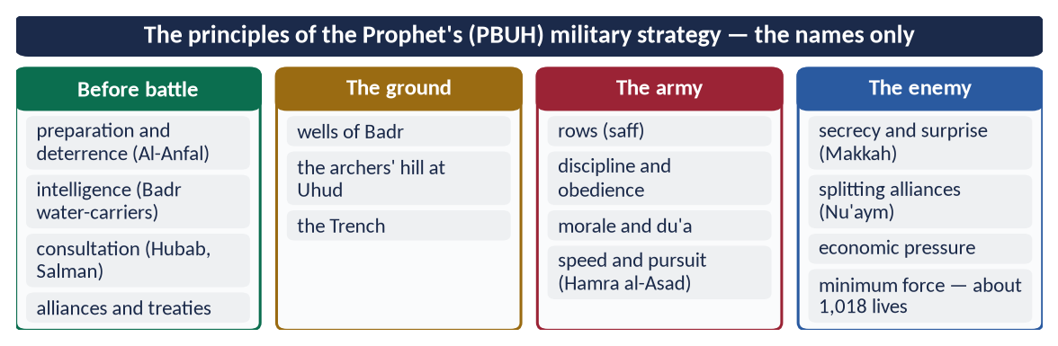
Figure 11 · At a glance — the principles of the Prophet's ﷺ military strategy — the names only. The detail is in the sections above.

6.4 His character as commander in the battlefield (2019)

(1) Courage at the front
✦ HADITH
كُنَّا إِذَا احْمَرَّ الْبَأْسُ نَتَّقِي بِهِ
“When the fighting grew fierce, we used to take shelter behind him.” (Muslim)
➜ Al-Bara' (RA): the bravest man in battle was the one closest to the enemy — the Prophet ﷺ.

At Hunayn, when the army broke under ambush, he stood his ground on his mule calling:
✦ HADITH
أَنَا النَّبِيُّ لَا كَذِبْ، أَنَا ابْنُ عَبْدِ الْمُطَّلِبْ
“I am the Prophet, no lie; I am the son of Abd al-Muttalib.” (Al-Bukhari and Muslim)
➜ He named himself to the enemy when others fled; the army regrouped around him.

At Uhud he was wounded — a tooth broken, his helmet driven into his face — yet stayed on the field.

(2) Sharing every hardship
He dug the trench and carried earth until the dust covered his stomach; he tied a stone to his stomach from hunger like the others (Al-Bukhari). At Badr there was one camel for every three men; he took his turn walking.

(3) Consultation and humility
He accepted the advice of a young Companion (Hubab) and of a Persian (Salman), and followed the majority at Uhud.

(4) Trust in Allah with full preparation
Before Badr he arranged every row, then spent the night in du'a until his cloak fell from his shoulders.

(5) Keeping his word even in war
✦ HADITH
نَفِي لَهُمْ بِعَهْدِهِمْ، وَنَسْتَعِينُ اللَّهَ عَلَيْهِمْ
“We will keep our word to them, and seek Allah's help against them.” (Muslim)
➜ Hudhayfah and his father had been released by the Quraysh on a promise not to fight; though every man counted at Badr, he sent them away.

(6) Justice to his own soldiers
At Badr he poked Sawad ibn Ghaziyyah (RA) with an arrow to straighten the row; Sawad said, 'You have hurt me — give me retaliation.' The commander bared his stomach; Sawad kissed it instead (Ibn Hisham).

(7) Mercy to prisoners and the defeated
✦ QURAN
﴿وَيُطۡعِمُونَ ٱلطَّعَامَ عَلَىٰ حُبِّهِۦ مِسۡكِينٗا وَيَتِيمٗا وَأَسِيرًا﴾
“And they give food in spite of love for it to the needy, the orphan, and the captive.” (Al-Insan, Quran)
➜ They give food, though they love it, to the poor, the orphan and the captive.

The prisoners of Badr were fed bread while their captors ate dates; they were freed for ransom or for teaching ten children. At Hunayn he returned 6,000 captives of Hawazin to their families.

(8) Forgiveness at the moment of victory
He entered Makkah with his head bowed so low that his beard almost touched the saddle, and announced a general amnesty (Chapter 3).

(9) Patience in setback
After Uhud he did not blame the archers publicly; the Quran told him to pardon them and consult them still (Aal-e-Imran 159).

(10) Never wishing for war
✦ HADITH
لَا تَتَمَنَّوْا لِقَاءَ الْعَدُوِّ، وَسَلُوا اللَّهَ الْعَافِيَةَ، فَإِذَا لَقِيتُمُوهُمْ فَاصْبِرُوا
“Do not wish to meet the enemy; ask Allah for safety. But when you meet them, be steadfast.” (Al-Bukhari and Muslim)
➜ The commander prayed for peace and prepared for war.

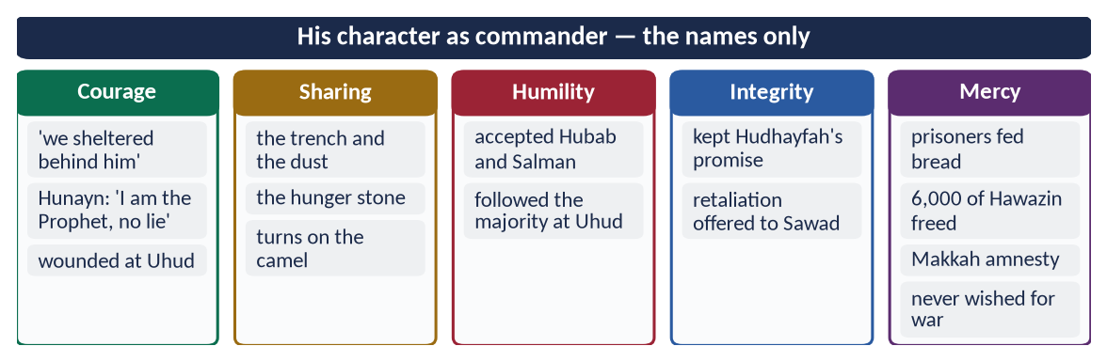
Figure 12 · At a glance — his character as commander — the names only. The detail is in the sections above.

6.5 What non-Muslim and military writers say
✦ SCHOLARLY VIEW
Sir John Bagot Glubb (Glubb Pasha) · The Life and Times of Muhammad (1970)
Glubb, a British general who commanded Arab soldiers for many years, judged that the Prophet's ﷺ military success came less from tactics than from his grasp of politics and morale — his hold on the minds and loyalty of his men.
➜ A professional soldier's view.

✦ SCHOLARLY VIEW
Dr Muhammad Hamidullah · The Battlefields of the Prophet Muhammad
Hamidullah visited and mapped the battlefields of Badr, Uhud and the Trench and showed that each choice of ground and each manoeuvre was deliberate strategy, fitted to terrain, numbers and supply — not accident.
➜ The scholar to quote on military strategy.

EXAMINER'S EYE · THREE DIFFERENT DEMANDS
2016 'characteristics of a military strategist' and 2023 'role as a model for military strategy' want the principles (6.3) — with the model for today (Pakistan's doctrine of deterrence, discipline, intelligence). 2019 'character in the battlefields as commander' wants personal qualities (6.4) — courage, sharing, justice, mercy. Do not give the same answer to both.

Chapter 7 · The Purpose of the Ghazwat: War for Peace
Asked in 2024: 'The main purpose of Ghazwat-e-Nabawi was to establish peace. Explain.'

7.1 Jihad and Qital — the terms
Jihad (جِهَاد) means striving — against the self, with the tongue and pen, with wealth, and in the last resort with arms. Qital (قِتَال) is armed fighting only. The Makkan verses of jihad (Al-Furqan 52: 'strive against them with the Quran') came before any fighting was allowed.

7.2 The Quranic conditions of war

(1) Permission only after persecution
✦ QURAN
﴿أُذِنَ لِلَّذِينَ يُقَٰتَلُونَ بِأَنَّهُمۡ ظُلِمُواْۚ وَإِنَّ ٱللَّهَ عَلَىٰ نَصۡرِهِمۡ لَقَدِيرٌ﴾
“Permission [to fight] has been given to those who are being fought, because they were wronged. And indeed, Allah is competent to give them victory.” (Al-Hajj, Quran)
➜ Permission to fight is given to those who are fought against because they were wronged.

✦ QURAN
﴿… وَلَوۡلَا دَفۡعُ ٱللَّهِ ٱلنَّاسَ بَعۡضَهُم بِبَعۡضٖ لَّهُدِّمَتۡ صَوَٰمِعُ وَبِيَعٞ وَصَلَوَٰتٞ وَمَسَٰجِدُ يُذۡكَرُ فِيهَا ٱسۡمُ ٱللَّهِ كَثِيرٗاۗ …﴾
“Were it not that Allah checks some people by means of others, monasteries, churches, synagogues and mosques — in which Allah's name is much mentioned — would have been demolished.” (Al-Hajj, Quran)
➜ Without self-defence, monasteries, churches, synagogues and mosques would be destroyed — war to protect the freedom of worship of all.

(2) Only against those who fight
✦ QURAN
﴿وَقَٰتِلُواْ فِي سَبِيلِ ٱللَّهِ ٱلَّذِينَ يُقَٰتِلُونَكُمۡ وَلَا تَعۡتَدُوٓاْۚ إِنَّ ٱللَّهَ لَا يُحِبُّ ٱلۡمُعۡتَدِينَ﴾
“Fight in the way of Allah those who fight you but do not transgress. Indeed. Allah does not like transgressors.” (Al-Baqarah, Quran)
➜ Fight those who fight you, but do not transgress — Allah does not love transgressors.

(3) To end persecution
✦ QURAN
﴿وَقَٰتِلُوهُمۡ حَتَّىٰ لَا تَكُونَ فِتۡنَةٞ وَيَكُونَ ٱلدِّينُ لِلَّهِۖ فَإِنِ ٱنتَهَوۡاْ فَلَا عُدۡوَٰنَ إِلَّا عَلَى ٱلظَّـٰلِمِينَ﴾
“Fight them until there is no [more] fitnah and [until] worship is [acknowledged to be] for Allah. But if they cease, then there is to be no aggression except against the oppressors.” (Al-Baqarah, Quran)
➜ Fight until there is no more fitnah (persecution); if they stop, there is no hostility except against oppressors.

(4) For the oppressed
✦ QURAN
﴿وَمَا لَكُمۡ لَا تُقَٰتِلُونَ فِي سَبِيلِ ٱللَّهِ وَٱلۡمُسۡتَضۡعَفِينَ مِنَ ٱلرِّجَالِ وَٱلنِّسَآءِ وَٱلۡوِلۡدَٰنِ …﴾
“What is wrong with you that you do not fight in the cause of Allah and for the oppressed among men, women and children?” (An-Nisa, Quran)
➜ Why do you not fight for the oppressed men, women and children?

(5) Peace as soon as it is offered
✦ QURAN
﴿وَإِن جَنَحُواْ لِلسَّلۡمِ فَٱجۡنَحۡ لَهَا وَتَوَكَّلۡ عَلَى ٱللَّهِۚ إِنَّهُۥ هُوَ ٱلسَّمِيعُ ٱلۡعَلِيمُ﴾
“And if they incline to peace, then incline to it [also] and rely upon Allah. Indeed, it is He who is the Hearing, the Knowing.” (Al-Anfal, Quran)
➜ 'If they incline to peace, incline to it and rely on Allah.'

✦ QURAN
﴿… فَإِنِ ٱعۡتَزَلُوكُمۡ فَلَمۡ يُقَٰتِلُوكُمۡ وَأَلۡقَوۡاْ إِلَيۡكُمُ ٱلسَّلَمَ فَمَا جَعَلَ ٱللَّهُ لَكُمۡ عَلَيۡهِمۡ سَبِيلٗا﴾
“If they withdraw from you, do not fight you and offer you peace, then Allah has given you no way against them.” (An-Nisa, Quran)
➜ If they withdraw and offer peace, Allah gives you no way against them.

7.3 The causes of the Ghazwat — each one for peace
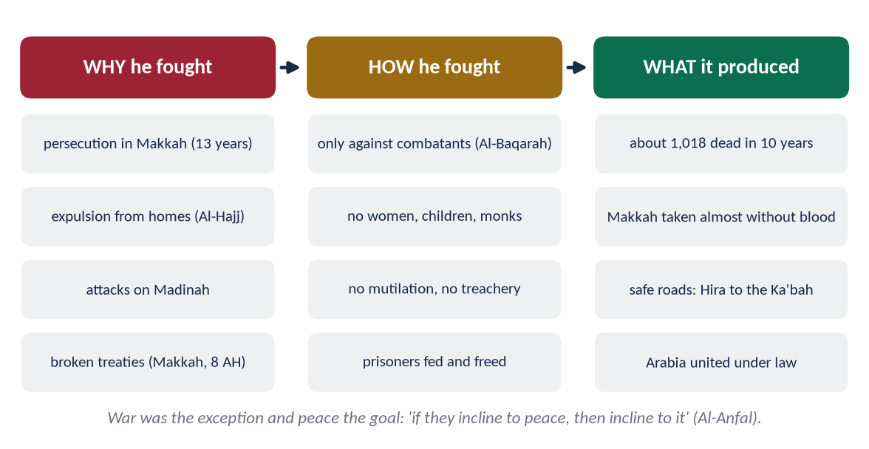
Figure 13 · Why he fought, how he fought and what it produced.
Ghazwah | Cause | How it served peace
Badr (2 AH) | Quraysh army marched to protect its caravan and crush Madinah | Broke the Quraysh claim to rule Arabia by force
Uhud (3 AH) | Quraysh attack on Madinah to avenge Badr | Defence of the city
Khandaq (5 AH) | 10,000 Confederates besieged Madinah | After it: 'Now we will go to them, they will not come to us' (Al-Bukhari) — the end of attacks on Madinah
Khaybar (7 AH) | Khaybar was the centre of conspiracy; it organised the Confederates | Ended the northern threat; peace terms left the land with its people
Makkah (8 AH) | The Quraysh broke Hudaybiyyah by helping Banu Bakr kill Khuza'ah | Taken almost without bloodshed; general amnesty
Hunayn (8 AH) | Hawazin gathered 20,000 to attack | Captives returned; Hawazin became Muslim allies
Tabuk (9 AH) | Byzantine threat on the northern border | No battle; treaties of protection with border towns

7.4 The rules of war — peace inside war
✦ HADITH
اغْزُوا بِاسْمِ اللَّهِ ... وَلَا تَغُلُّوا، وَلَا تَغْدِرُوا، وَلَا تَمْثُلُوا، وَلَا تَقْتُلُوا وَلِيدًا
“Fight in the name of Allah … do not steal from the spoils, do not betray, do not mutilate, and do not kill a child.” (Muslim)
➜ His standing orders to every commander (the hadith of Buraydah): the enemy must also be invited to Islam or to peace before any fighting.

✦ HADITH
فَنَهَى رَسُولُ اللَّهِ ﷺ عَنْ قَتْلِ النِّسَاءِ وَالصِّبْيَانِ
“The Messenger of Allah ﷺ forbade the killing of women and children.” (Al-Bukhari and Muslim)
➜ Seeing a woman killed in a battle, he condemned it — non-combatants are protected.

✦ FROM THE SIRAH
لَا تَقْتُلَنَّ امْرَأَةً وَلَا صَبِيًّا وَلَا كَبِيرًا هَرِمًا، وَلَا تَقْطَعَنَّ شَجَرًا مُثْمِرًا، وَلَا تُخَرِّبَنَّ عَامِرًا
“Do not kill a woman, a child or an old man; do not cut down a fruit-bearing tree; do not destroy a populated place.” (Muwatta Imam Malik)
➜ Hazrat Abu Bakr (RA) passed on the Prophetic rules to his army for Syria — the environment and property protected too.

The Quran adds the protection of those who seek refuge:
✦ QURAN
﴿وَإِنۡ أَحَدٞ مِّنَ ٱلۡمُشۡرِكِينَ ٱسۡتَجَارَكَ فَأَجِرۡهُ حَتَّىٰ يَسۡمَعَ كَلَٰمَ ٱللَّهِ ثُمَّ أَبۡلِغۡهُ مَأۡمَنَهُۥۚ ذَٰلِكَ بِأَنَّهُمۡ قَوۡمٞ لَّا يَعۡلَمُونَ﴾
“And if any one of the polytheists seeks your protection, then grant him protection so that he may hear the words of Allah. Then deliver him to his place of safety. That is because they are a people who do not know.” (At-Tawbah, Quran)
➜ If a polytheist seeks your protection, protect him and take him to his place of safety.

7.5 The proof — what the Ghazwat produced

(1) The least bloodshed in any revolution
Record | Figure
Muslims martyred in all battles | about 259
Enemy killed | about 759
Total in ten years | about 1,018 (Qazi Sulaiman Mansurpuri)
Area brought under peace | about 1 million square miles (Arabian Peninsula)

Compare: the First World War killed about 17 million, the Second about 70–85 million.

(2) The goal was guidance, not killing
✦ HADITH
فَوَاللَّهِ لَأَنْ يَهْدِيَ اللَّهُ بِكَ رَجُلًا وَاحِدًا خَيْرٌ لَكَ مِنْ أَنْ يَكُونَ لَكَ حُمْرُ النَّعَمِ
“By Allah, that Allah guides one man through you is better for you than the finest red camels.” (Al-Bukhari and Muslim)
➜ His words to Ali (RA) at Khaybar, as he handed him the flag: invite them first.

(3) Safe roads — the prophecy fulfilled
✦ HADITH
فَلَيُوشِكَنَّ أَنْ تَرَى الظَّعِينَةَ تَرْتَحِلُ مِنَ الْحِيرَةِ حَتَّى تَطُوفَ بِالْكَعْبَةِ لَا تَخَافُ أَحَدًا إِلَّا اللَّهَ
“You will soon see a woman travel alone from Hira to circle the Ka'bah, fearing no one but Allah.” (Al-Bukhari)
➜ Adi ibn Hatim (RA) later said: 'I saw it with my own eyes' — the Ghazwat ended in security.

(4) The enemies became brothers
The Quraysh of Makkah, the Hawazin of Hunayn, the Thaqif of Taif — all joined within two years of their last battle.
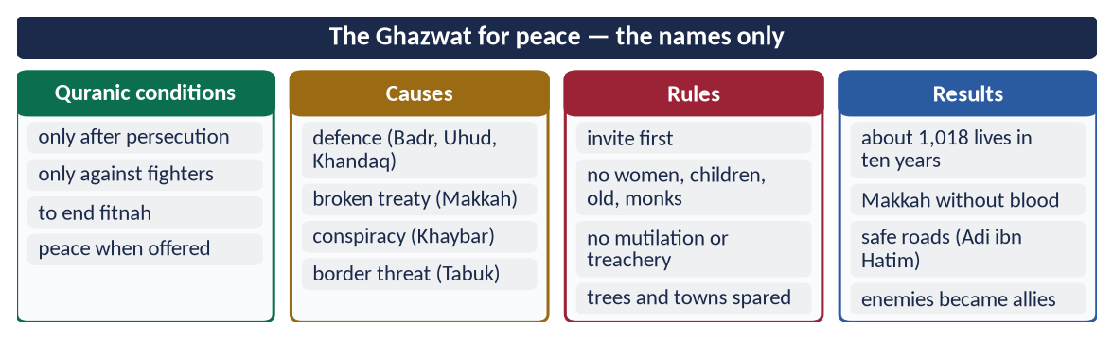
Figure 14 · At a glance — the Ghazwat for peace — the names only. The detail is in the sections above.
TRAP · 'ISLAM WAS SPREAD BY THE SWORD'
Answer it with facts, not emotion: no compulsion in religion (Al-Baqarah); the largest Muslim countries today — Indonesia and Malaysia — were never conquered by Muslim armies; most of Arabia entered Islam after Hudaybiyyah, in peace; the conquered Christians and Jews kept their faith for centuries under Muslim rule.

Chapter 8 · The Prophet ﷺ as Peace Maker
The most asked role: greatest peace maker — reconciliation with pagans, Jews and Christians (2017), prophet of peace and safety (2018), prophet of peace for the contemporary transnational world (2022).

8.1 Peace is the name of the religion

(1) The words
Islam (إِسْلَام) and salam (سَلَام) come from one root, s-l-m: peace, safety and submission. As-Salam (اَلسَّلَام) is a name of Allah (Al-Hashr 23); Paradise is Dar as-Salam, the Home of Peace; the Muslim greeting is 'peace be upon you'.
✦ QURAN
﴿وَٱللَّهُ يَدۡعُوٓاْ إِلَىٰ دَارِ ٱلسَّلَٰمِ وَيَهۡدِي مَن يَشَآءُ إِلَىٰ صِرَٰطٖ مُّسۡتَقِيمٖ﴾
“And Allah invites to the Home of Peace and guides whom He wills to a straight path.” (Yunus, Quran)
➜ Allah invites to the Home of Peace (Dar as-Salam).

✦ QURAN
﴿وَمَآ أَرۡسَلۡنَٰكَ إِلَّا رَحۡمَةٗ لِّلۡعَٰلَمِينَ﴾
“And We have not sent you, [O Muhammad], except as a mercy to the worlds.” (Al-Anbiya, Quran)
➜ He was sent as a mercy to all the worlds — peace is the form that mercy takes in society.

(2) Peace as the definition of a Muslim — 'peace and safety' (2018)
✦ HADITH
الْمُسْلِمُ مَنْ سَلِمَ الْمُسْلِمُونَ مِنْ لِسَانِهِ وَيَدِهِ
“The Muslim is the one from whose tongue and hand the Muslims are safe.” (Al-Bukhari and Muslim)
➜ The word salima — safe — defines the Muslim.

✦ HADITH
وَالْمُؤْمِنُ مَنْ أَمِنَهُ النَّاسُ عَلَى دِمَائِهِمْ وَأَمْوَالِهِمْ
“And the believer is the one whom people trust with their lives and their property.” (Al-Tirmidhi and Al-Nasa'i)
➜ Here the word is people (an-nas), not only Muslims — the believer is a source of safety (aman) for all humanity.

✦ HADITH
أَفْشُوا السَّلَامَ بَيْنَكُمْ
“Spread peace (the greeting of peace) among yourselves.” (Muslim)
➜ Peace begins as a daily habit.

(3) The sanctity of life
✦ QURAN
﴿… مَن قَتَلَ نَفۡسَۢا بِغَيۡرِ نَفۡسٍ أَوۡ فَسَادٖ فِي ٱلۡأَرۡضِ فَكَأَنَّمَا قَتَلَ ٱلنَّاسَ جَمِيعٗا وَمَنۡ أَحۡيَاهَا فَكَأَنَّمَآ أَحۡيَا ٱلنَّاسَ جَمِيعٗاۚ …﴾
“Whoever kills a soul — unless for a soul or for corruption in the land — it is as if he had slain mankind entirely; and whoever saves one, it is as if he had saved mankind entirely.” (Al-Ma'idah, Quran)
➜ Killing one innocent soul is like killing all mankind; saving one is like saving all mankind.

8.2 Peace maker before Prophethood
- (a) Hilf al-Fudul — the pact to protect the oppressed of Makkah (Chapter 5).
- (b) The Black Stone (605) — the cloak that prevented a civil war among the clans.
- (c) Al-Amin — trusted by all as an arbiter because he was trusted by all as honest.

8.3 Peace inside Madinah — the Muslim society

(1) Ending the war of Aws and Khazraj
The two tribes of Yathrib had fought for over a century; the last battle, Bu'ath (617), came only five years before the Hijrah. Through faith they became one people, the Ansar.
✦ QURAN
﴿وَٱعۡتَصِمُواْ بِحَبۡلِ ٱللَّهِ جَمِيعٗا وَلَا تَفَرَّقُواْۚ وَٱذۡكُرُواْ نِعۡمَتَ ٱللَّهِ عَلَيۡكُمۡ إِذۡ كُنتُمۡ أَعۡدَآءٗ فَأَلَّفَ بَيۡنَ قُلُوبِكُمۡ فَأَصۡبَحۡتُم بِنِعۡمَتِهِۦٓ إِخۡوَٰنٗا …﴾
“And hold firmly to the rope of Allah all together and do not become divided. Remember Allah's favour upon you: you were enemies, and He brought your hearts together, and by His favour you became brothers.” (Aal-e-Imran, Quran)
➜ 'You were enemies and He brought your hearts together; you became brothers.'

(2) The Brotherhood — Mu'akhat
He paired each Muhajir with an Ansari as brothers; the Ansar shared homes, land and trade. The refugee problem was solved without a camp.
✦ QURAN
﴿… وَيُؤۡثِرُونَ عَلَىٰٓ أَنفُسِهِمۡ وَلَوۡ كَانَ بِهِمۡ خَصَاصَةٞۚ …﴾
“And they give [the Emigrants] preference over themselves, even though they are in need.” (Al-Hashr, Quran)
➜ The Ansar preferred others over themselves, even when in need.

(3) Abolishing blood feuds
✦ HADITH
وَدِمَاءُ الْجَاهِلِيَّةِ مَوْضُوعَةٌ، وَإِنَّ أَوَّلَ دَمٍ أَضَعُ مِنْ دِمَائِنَا دَمُ ابْنِ رَبِيعَةَ بْنِ الْحَارِثِ
“The blood-claims of the Jahiliyyah are abolished, and the first claim I abolish is that of Ibn Rabi'ah ibn al-Harith — from my own family.” (Muslim)
➜ In the Farewell Sermon he ended the chain of revenge, starting with his own family.

✦ HADITH
إِنَّ دِمَاءَكُمْ وَأَمْوَالَكُمْ حَرَامٌ عَلَيْكُمْ كَحُرْمَةِ يَوْمِكُمْ هَذَا
“Your lives and your property are sacred to one another, like the sanctity of this day of yours.” (Al-Bukhari and Muslim)
➜ The charter of human security.

(4) Equality — removing the roots of conflict
✦ FROM THE SIRAH
لَا فَضْلَ لِعَرَبِيٍّ عَلَى عَجَمِيٍّ، وَلَا لِعَجَمِيٍّ عَلَى عَرَبِيٍّ، وَلَا لِأَحْمَرَ عَلَى أَسْوَدَ، وَلَا أَسْوَدَ عَلَى أَحْمَرَ، إِلَّا بِالتَّقْوَى
“No Arab is superior to a non-Arab, nor a non-Arab to an Arab, nor a white to a black, nor a black to a white — except by taqwa.” (Musnad Ahmad (the Farewell Sermon))
➜ Racism is a root of war; he abolished it.

(5) Reconciling quarrels
✦ QURAN
﴿وَإِن طَآئِفَتَانِ مِنَ ٱلۡمُؤۡمِنِينَ ٱقۡتَتَلُواْ فَأَصۡلِحُواْ بَيۡنَهُمَاۖ …﴾
“And if two groups of the believers fight, then make peace between them.” (Al-Hujurat, Quran)
➜ If two groups of believers fight, make peace between them — with justice.

He went himself to Banu Amr ibn Awf at Quba to settle a quarrel, and was late for prayer because of it (Al-Bukhari).

8.4 Reconciliation with the pagans (Mushrikin)
- (a) Thirteen years of patience in Makkah — no retaliation under persecution.
- (b) Taif — du'a instead of destruction (Chapter 3).
- (c) The Treaty of Hudaybiyyah (6 AH) — he accepted hard terms to secure ten years of peace (Chapter 10).
✦ HADITH
وَالَّذِي نَفْسِي بِيَدِهِ لَا يَسْأَلُونِي خُطَّةً يُعَظِّمُونَ فِيهَا حُرُمَاتِ اللَّهِ إِلَّا أَعْطَيْتُهُمْ إِيَّاهَا
“By the One in whose hand is my soul, whatever plan they propose that respects the sanctities of Allah, I will grant it to them.” (Al-Bukhari)
➜ At Hudaybiyyah he declared himself ready to accept any peace that respected the sacred.

- (d) The Conquest of Makkah (8 AH) — the amnesty: 'Go, you are free'; 'Whoever enters the house of Abu Sufyan is safe; whoever shuts his door is safe; whoever enters the Mosque is safe' (Muslim) — safety made easy for everyone.
- (e) Hunayn — 6,000 captives of Hawazin returned.
- (f) Protection for those who ask — At-Tawbah 6.

8.5 Reconciliation with the Jews
- (a) The Charter of Madinah — the Jews of Madinah made one community with the believers, with their own religion (Chapter 9).
- (b) Justice in disputes — a Muslim who accused a Jew falsely was exposed by revelation (An-Nisa 105–107, the case of Tu'mah).
- (c) Khaybar — after the battle, the land was left with the Jews to cultivate for half of the produce (Al-Bukhari); the poisoner was forgiven.
- (d) Social relations — he visited a sick Jewish boy, stood for a Jewish funeral ('is it not a soul?'), traded with Jews and pledged his armour with one.
The three tribes — Qaynuqa (2 AH), Nadir (4 AH) and Qurayzah (5 AH) — lost their place in Madinah only after each broke the Charter; the tribes that kept it stayed in peace.

8.6 Reconciliation with the Christians
- (a) Abyssinia — the persecuted Muslims found refuge with the Christian Negus; the Prophet ﷺ prayed the funeral prayer in absence for him (Al-Bukhari).
- (b) The delegation of Najran (9 AH) — lodged in the Mosque, allowed to pray there; a treaty guaranteed their churches, clergy, religion and property (Abu Dawud; Abu Ubayd, Kitab al-Amwal).
- (c) Aylah (Tabuk, 9 AH) — the Christian ruler Yuhanna ibn Ru'bah was given a covenant of protection for his people, ships and caravans.
- (d) The common word — Aal-e-Imran 64, written to Heraclius.
✦ QURAN
﴿… وَلَتَجِدَنَّ أَقۡرَبَهُم مَّوَدَّةٗ لِّلَّذِينَ ءَامَنُواْ ٱلَّذِينَ قَالُوٓاْ إِنَّا نَصَٰرَىٰۚ ذَٰلِكَ بِأَنَّ مِنۡهُمۡ قِسِّيسِينَ وَرُهۡبَانٗا وَأَنَّهُمۡ لَا يَسۡتَكۡبِرُونَ﴾
“You will find the nearest of them in affection to the believers those who say, 'We are Christians' — that is because among them are priests and monks, and they are not arrogant.” (Al-Ma'idah, Quran)
➜ The nearest in affection to the believers are those who say 'We are Christians' — among them are priests and monks, and they are not arrogant.

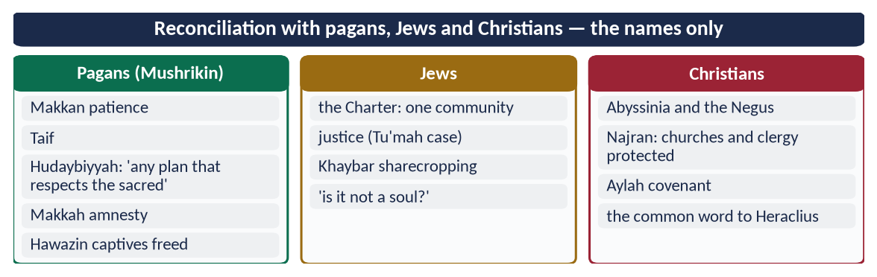
Figure 15 · At a glance — reconciliation with pagans, Jews and Christians — the names only. The detail is in the sections above.

8.7 A prophet of peace for the contemporary transnational world (2022)
Today's world is transnational: people, trade, ideas and conflicts cross borders; migrants and minorities live everywhere; the UN, treaties and international law govern relations. The Sirah speaks to each of these.
Today's need | The Prophetic model | Modern parallel
Human dignity and equality | Al-Isra 70: 'We honoured the children of Adam'; the Farewell Sermon | UDHR (1948), Article 1
Rule of law and treaties | Al-Isra 34: fulfil every covenant; Hudaybiyyah honoured even when painful | UN Charter; Vienna Convention on Treaties (1969)
Refugees and asylum | Hijrah to Abyssinia; Mu'akhat in Madinah; At-Tawbah 6 | Refugee Convention (1951)
Pluralism and minorities | Charter of Madinah; Najran treaty | Minority rights; Article 36, Constitution of Pakistan
Interfaith dialogue | Aal-e-Imran 64; Najran debate | Amman Message (2004); A Common Word (2007)
Humane rules of war | Buraydah hadith; no women, children, monks | Geneva Conventions (1949)
Diplomatic immunity | 'Envoys are not killed' (Abu Dawud) | Vienna Convention on Diplomatic Relations (1961)
Economic justice | Zakat; no hoarding; no riba | UN Sustainable Development Goals
Environment | Trees not to be cut in war; 'plant the sapling even at the Hour' (Ahmad) | Paris Agreement (2015)

✦ QURAN
﴿يَـٰٓأَيُّهَا ٱلنَّاسُ إِنَّا خَلَقۡنَٰكُم مِّن ذَكَرٖ وَأُنثَىٰ وَجَعَلۡنَٰكُمۡ شُعُوبٗا وَقَبَآئِلَ لِتَعَارَفُوٓاْۚ إِنَّ أَكۡرَمَكُمۡ عِندَ ٱللَّهِ أَتۡقَىٰكُمۡۚ إِنَّ ٱللَّهَ عَلِيمٌ خَبِيرٞ﴾
“O mankind, indeed We have created you from male and female and made you peoples and tribes that you may know one another. Indeed, the most noble of you in the sight of Allah is the most righteous of you. Indeed, Allah is Knowing and Acquainted.” (Al-Hujurat, Quran)
➜ Mankind was made into nations and tribes to know one another — the Quranic basis of a transnational order.

✦ SCHOLARLY VIEW
George Bernard Shaw · The Genuine Islam (1936)
Shaw wrote that if a man like Muhammad were to assume the leadership of the modern world, he would succeed in solving its problems in a way that would bring it the much-needed peace and happiness.
➜ A Western writer's view of the Prophet ﷺ as a peace maker for the modern world.

DEBATE · IS THE PROPHETIC MODEL PRACTICAL IN A WORLD OF NATION-STATES?
Yes, in principle: treaties, immunity, protection of non-combatants and minorities are the same principles the modern world has adopted. The challenge is practice: Muslim states must show these principles themselves — honouring treaties, protecting minorities and resolving disputes through the OIC and dialogue.

Chapter 9 · The Charter of Madinah as a Social Contract
Asked twice in almost the same words: 2020 and 2023.

9.1 What the Charter is
Mithaq al-Madinah (مِيثَاقُ الْمَدِينَة), also Sahifat al-Madinah (صَحِيفَةُ الْمَدِينَة), is the written agreement the Prophet ﷺ made in 1 AH / 622 among the Muhajirin, the Ansar and the Jewish tribes of Yathrib. It is preserved by Ibn Ishaq (in Ibn Hisham) and Abu Ubayd (Kitab al-Amwal). It has about fifty clauses — counted variously from 47 to 53.
✦ SCHOLARLY VIEW
Dr Muhammad Hamidullah · The First Written Constitution in the World (1941)
Hamidullah called the Charter 'the first written constitution of the world' — a document that defined a state, its citizens, its authority and its law, centuries before Magna Carta (1215) or the American Constitution (1787).
➜ The most-quoted scholarly judgement on the Charter.

9.2 The background — Yathrib before the Hijrah
- Tribal anarchy: the Aws and Khazraj had fought for generations; Bu'ath (617) had exhausted them.
- No state: no ruler, no court, no common law — the strong ruled.
- Mixed population: Arabs (Aws, Khazraj), Jews (Qaynuqa, Nadir, Qurayzah and smaller clans), and now the Muhajirin.
- External threat: the Quraysh wanted to destroy the Muslims.
This is exactly the 'state of nature' of the social-contract philosophers.

9.3 The parties
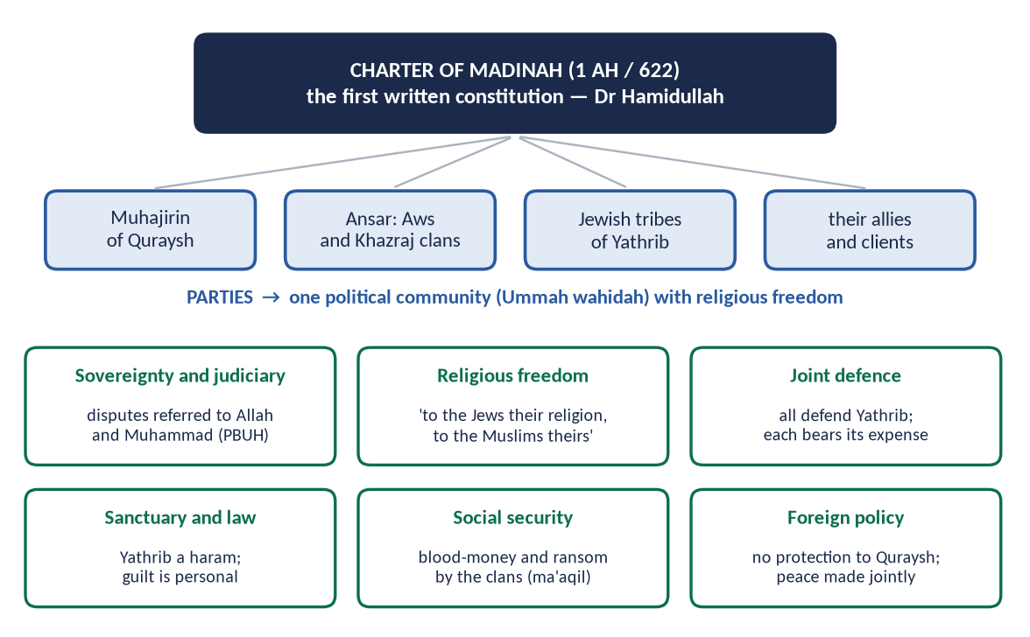
Figure 16 · The Charter of Madinah — the parties and the main provisions.

9.4 The main provisions, with its own words

(1) One political community
✦ FROM THE SIRAH
إِنَّهُمْ أُمَّةٌ وَاحِدَةٌ مِنْ دُونِ النَّاسِ
“They are one community (Ummah) distinct from all other people.” (Sirat Ibn Hisham (the Charter))
➜ A new political identity above tribe — the birth of citizenship.

(2) Religious freedom
✦ FROM THE SIRAH
وَإِنَّ يَهُودَ بَنِي عَوْفٍ أُمَّةٌ مَعَ الْمُؤْمِنِينَ، لِلْيَهُودِ دِينُهُمْ وَلِلْمُسْلِمِينَ دِينُهُمْ
“The Jews of Banu Awf are one community with the believers: to the Jews their religion and to the Muslims theirs.” (Sirat Ibn Hisham (the Charter))
➜ Citizenship without conversion — freedom of faith written into law.

(3) The final authority and judiciary
✦ FROM THE SIRAH
وَإِنَّكُمْ مَهْمَا اخْتَلَفْتُمْ فِيهِ مِنْ شَيْءٍ فَإِنَّ مَرَدَّهُ إِلَى اللَّهِ وَإِلَى مُحَمَّدٍ
“Whatever you differ about, it is to be referred to Allah and to Muhammad.” (Sirat Ibn Hisham (the Charter))
➜ Sovereignty of Allah and a central judiciary — the end of tribal self-help.

✦ QURAN
﴿… أَطِيعُواْ ٱللَّهَ وَأَطِيعُواْ ٱلرَّسُولَ وَأُوْلِي ٱلۡأَمۡرِ مِنكُمۡۖ فَإِن تَنَٰزَعۡتُمۡ فِي شَيۡءٖ فَرُدُّوهُ إِلَى ٱللَّهِ وَٱلرَّسُولِ …﴾
“Obey Allah and obey the Messenger and those in authority among you; and if you disagree over anything, refer it to Allah and the Messenger.” (An-Nisa, Quran)
➜ Obey Allah, the Messenger and those in authority; refer disputes to Allah and the Messenger — the same principle.

(4) Joint defence
✦ FROM THE SIRAH
وَإِنَّ بَيْنَهُمُ النَّصْرَ عَلَى مَنْ حَارَبَ أَهْلَ هَذِهِ الصَّحِيفَةِ
“They must help one another against whoever fights the people of this document.” (Sirat Ibn Hisham (the Charter))
➜ Collective security; each party bears its own war expenses; no one gives protection to the Quraysh.

(5) Madinah a sanctuary
✦ FROM THE SIRAH
وَإِنَّ يَثْرِبَ حَرَامٌ جَوْفُهَا لِأَهْلِ هَذِهِ الصَّحِيفَةِ
“The valley of Yathrib is a sanctuary for the people of this document.” (Sirat Ibn Hisham (the Charter))
➜ Madinah is a haram — no bloodshed inside it.

(6) Rule of law and personal responsibility
- Guilt is personal: 'a person is responsible only for his own crime' — no collective punishment of the tribe.
- Justice for the oppressed: all must stand against the one who does wrong, 'even if he is the son of one of them'.
- Blood-money and ransom paid by the clans as before (the ma'aqil system) — continuity with a welfare function.
- Neighbours and protected persons treated like oneself.
Clause group | Modern constitutional idea
One Ummah above tribes | Citizenship; national identity
'To the Jews their religion…' | Freedom of religion; minority rights
Refer disputes to Allah and Muhammad ﷺ | Sovereignty; supreme court; rule of law
Help against whoever fights the parties | Defence pact; collective security
Yathrib a sanctuary | Territorial state; internal peace
Guilt is personal | Individual criminal liability
Blood-money by the clans | Social security
No protection to Quraysh | Common foreign policy

9.5 The Charter as a social contract — analysis

(1) What a social contract is
A social contract is the agreement by which individuals leave the 'state of nature' and form a political society, giving up some freedom in exchange for security and rights under a common authority.
Thinker | Work | Key idea
Thomas Hobbes | Leviathan (1651) | Life without a state is 'nasty, brutish and short'; people give power to a sovereign for security.
John Locke | Two Treatises (1689) | People consent to government to protect life, liberty and property; power is limited.
J. J. Rousseau | The Social Contract (1762) | The 'general will' — people bind themselves to laws they make together.

(2) The elements of a social contract in the Charter
Element | In the Charter of Madinah
State of nature | Tribal war and anarchy in Yathrib (Bu'ath)
Consent of the parties | Negotiated with the tribes after the pledges of Aqabah; written and agreed
Sovereign authority | Allah as sovereign; the Prophet ﷺ as head of state and final judge
Rights | Life, property, religion, protection of neighbours and clients
Duties | Joint defence, sharing costs, loyalty, no help to the enemy
Rule of law | Guilt personal; justice even against one's own son
Written document | Actual and written — not imagined like the Western theories

(3) How it goes beyond the Western social contract
- (a) Real, not hypothetical: Hobbes, Locke and Rousseau imagined a contract; the Charter was actually signed in 622.
- (b) Divine sovereignty: the source of law is Allah — not the people's will alone — so basic rights cannot be voted away.
- (c) Pluralism from the start: it united people of different religions, while Europe fought wars of religion until 1648.
- (d) Moral basis: loyalty rests on faith and justice, not on fear (Hobbes) or interest only.

(4) The Charter in operation
When the tribes of Qaynuqa, Nadir and Qurayzah broke its terms — by insult and aggression, a plot on the Prophet's ﷺ life, and joining the Confederates in war — they were dealt with under the contract they had signed. The clans that kept it remained in peace.

9.6 Relevance for Pakistan
- Objectives Resolution (1949): sovereignty belongs to Allah, exercised by the people as a trust — the principle of the Charter.
- Article 20 and Article 36 (freedom of religion; protection of minorities) — 'to the Jews their religion'.
- Federation of units: the Charter kept each clan's identity inside one state — a model for provincial harmony.
EXAMINER'S EYE · 'ANALYSE' MEANS COMPARE
Both questions say 'analyse as a social contract'. Listing clauses is not enough: define social contract, name Hobbes, Locke, Rousseau, then map each element onto the Charter (the table in 9.5) and show where the Charter goes beyond them.

Chapter 10 · The Treaty of Hudaybiyyah and the Peace Agreements of the Prophetic Era
Asked as 'Hudaybiyyah as a pact of peace' (2021) and 'the contents of the peace agreements and their parties' (2025).

10.1 The Treaty of Hudaybiyyah (Dhul Qa'dah 6 AH / March 628)

(1) Background
The Prophet ﷺ saw in a dream that he performed Umrah. He set out with about 1,400 Companions, in ihram, with sacrificial animals and no weapons of war except sheathed swords — a pilgrimage, not an attack. The Quraysh blocked him at Hudaybiyyah, about 20 km from Makkah.

(2) The pledge of Ridwan
When a rumour came that his envoy Uthman (RA) had been killed, the Companions pledged under a tree to stand by him to death.
✦ QURAN
﴿لَّقَدۡ رَضِيَ ٱللَّهُ عَنِ ٱلۡمُؤۡمِنِينَ إِذۡ يُبَايِعُونَكَ تَحۡتَ ٱلشَّجَرَةِ فَعَلِمَ مَا فِي قُلُوبِهِمۡ فَأَنزَلَ ٱلسَّكِينَةَ عَلَيۡهِمۡ وَأَثَٰبَهُمۡ فَتۡحٗا قَرِيبٗا﴾
“Certainly was Allah pleased with the believers when they pledged allegiance to you, [O Muhammad], under the tree, and He knew what was in their hearts, so He sent down tranquillity upon them and rewarded them with an imminent conquest.” (Al-Fath, Quran)
➜ Allah was pleased with the believers when they pledged allegiance under the tree.

(3) The negotiation
The Quraysh sent envoys; last came Suhayl ibn Amr. The Prophet ﷺ accepted every change of wording to save the peace:
- 'Bismillah ar-Rahman ar-Rahim' replaced by 'Bismika Allahumma'.
- 'Muhammad the Messenger of Allah' replaced by 'Muhammad ibn Abdullah'; when Ali (RA) would not erase it, the Prophet ﷺ erased it himself (Al-Bukhari).

(4) The terms
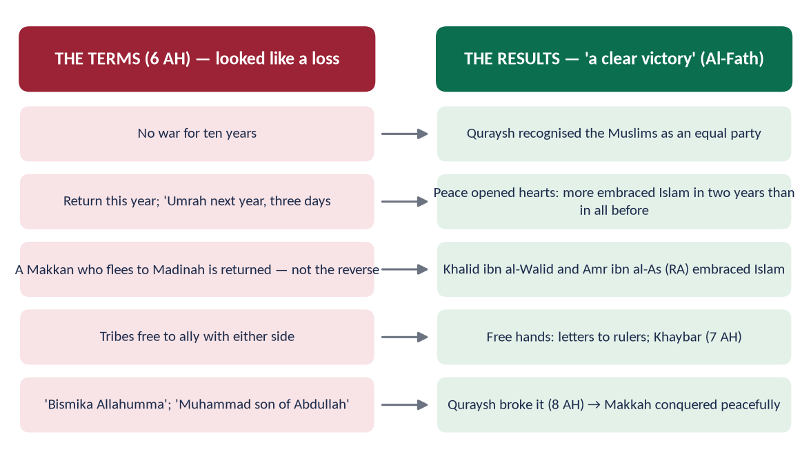
Figure 17 · The terms of Hudaybiyyah and their results.
# | Term
1 | No war for ten years; people to be safe.
2 | The Muslims return this year and come next year for Umrah of three days, with sheathed swords only.
3 | A Makkan who goes to Madinah without his guardian's permission is returned; a Muslim who goes to Makkah is not returned.
4 | Any tribe may ally with either side (Khuza'ah joined the Muslims, Banu Bakr the Quraysh).

(5) The Companions' grief and the Prophet's ﷺ vision
✦ HADITH
أَلَسْنَا عَلَى الْحَقِّ وَعَدُوُّنَا عَلَى الْبَاطِلِ؟ ... فَلِمَ نُعْطِي الدَّنِيَّةَ فِي دِينِنَا؟
“'Are we not on the truth and our enemy on falsehood? … Then why should we accept humiliation in our religion?'” (Al-Bukhari)
➜ Umar (RA) voiced the Companions' pain. The Prophet ﷺ replied: 'I am the Messenger of Allah; I do not disobey Him, and He is my helper.'

Abu Jandal (RA), son of Suhayl, arrived in chains and was returned under the treaty — the hardest test of keeping one's word.

(6) 'A clear victory'
✦ QURAN
﴿إِنَّا فَتَحۡنَا لَكَ فَتۡحٗا مُّبِينٗا﴾
“Indeed, We have given you, [O Muhammad], a clear conquest.” (Al-Fath, Quran)
➜ 'Indeed, We have given you a clear victory' — revealed on the way back, about a treaty the Companions saw as a defeat.

10.2 Hudaybiyyah as a pact of peace — its results
- (a) Recognition: the Quraysh signed as equals with the Muslims — the state of Madinah was recognised.
- (b) Peace opened the way for dawah:
✦ SCHOLARLY VIEW
Imam al-Zuhri · reported by Ibn Hisham
Al-Zuhri said that no victory in Islam was greater than Hudaybiyyah: when war ended and people met in safety and talked, everyone of sense who heard of Islam entered it — and in the two years after it as many entered Islam as in all the years before, or more.
➜ The proof: 1,400 at Hudaybiyyah, 10,000 at Makkah two years later.

- (c) Great men joined: Khalid ibn al-Walid and Amr ibn al-As (RA) accepted Islam.
- (d) Free hands: the letters to the rulers (Chapter 5) and the removal of the Khaybar threat (Chapter 11).
- (e) The painful clause undid itself: Abu Basir (RA) and other escaped Muslims, not allowed into Madinah, formed a group on the coast that threatened Quraysh trade; the Quraysh themselves asked for the clause to be dropped.
- (f) The Conquest of Makkah: the Quraysh broke the treaty by helping Banu Bakr against Khuza'ah; Makkah was then taken almost without bloodshed (8 AH).
REMEMBER · THE LESSONS OF HUDAYBIYYAH
Patience over emotion; flexibility in form, firmness in principle; keeping one's word even when it hurts (Abu Jandal); long-term vision over short-term pride; peace as a strategy that wins more than war.

10.3 The peace agreements of the Prophetic era — contents and parties (2025)
Agreement | Date | Parties | Main contents
Hilf al-Fudul | c. 590 | Clans of Quraysh (Hashim, Muttalib, Zuhrah, Taym, Asad) | Protect every wronged person in Makkah, citizen or stranger
Pledges of Aqabah | 621, 622 | The Prophet ﷺ and the Aws and Khazraj | First: faith and morals; second: protect him as their own families — the path to the Hijrah
Charter of Madinah | 1 AH / 622 | Muhajirin, Ansar, Jewish tribes of Yathrib | One community; religious freedom; joint defence; Prophet ﷺ as arbiter; Yathrib a sanctuary
Treaty with Banu Damrah | 2 AH | The Prophet ﷺ and Banu Damrah (chief Makhshi ibn Amr) | Mutual non-aggression and help — the first treaty with a non-Muslim tribe
Banu Mudlij, Juhaynah | 2 AH | Coastal tribes | Non-aggression; security of routes
Hudaybiyyah | 6 AH | Muslims and Quraysh (Suhayl ibn Amr) | Ten-year truce; Umrah next year; return of Makkan fugitives; free alliances
Khaybar and Fadak | 7 AH | Muslims and the Jews of Khaybar, Fadak | Land kept by its people; half the produce to the state; free to practise their religion
Tabuk treaties | 9 AH | Aylah (Yuhanna ibn Ru'bah), Adhruh, Jarba, Maqna, Dumat al-Jandal | Protection of life, ships, caravans and faith in return for jizyah
Najran | 9–10 AH | Christians of Najran | Protection of churches, clergy, religion and property; 2,000 robes a year; no interference in faith
Thaqif (Taif) | 9 AH | The delegation of Thaqif | Taif's valley protected; they accepted Islam

✦ FROM THE SIRAH
وَلِنَجْرَانَ وَحَاشِيَتِهَا جِوَارُ اللَّهِ وَذِمَّةُ مُحَمَّدٍ النَّبِيِّ عَلَى أَمْوَالِهِمْ وَمِلَّتِهِمْ وَبِيَعِهِمْ
“For Najran and its people there is the protection of Allah and the guarantee of Muhammad the Prophet — for their property, their religion and their churches.” (Imam Abu Yusuf, Kitab al-Kharaj; Ibn Sa'd (the treaty of Najran))
➜ A Christian community's rights guaranteed in writing.

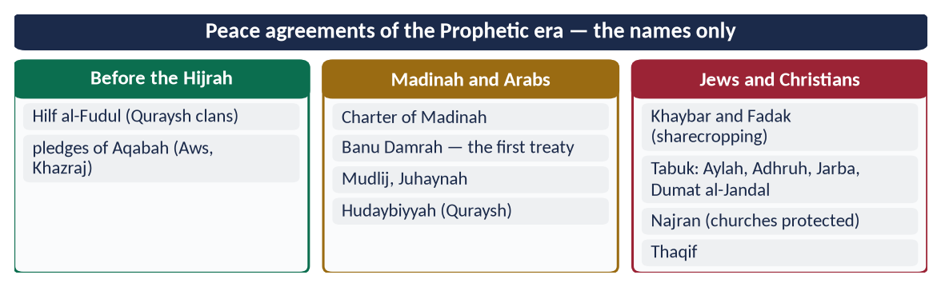
Figure 18 · At a glance — peace agreements of the Prophetic era — the names only. The detail is in the sections above.

Chapter 11 · The Battle of Khaybar (7 AH) and Its Benefits
Asked in 2021 as a short note: 'Benefits acquired from the Battle of Khaybar'.

11.1 The background
Khaybar, an oasis about 150 km north of Madinah, had eight strong forts (Na'im, Qamus, Watih, Sulalim and others) and rich date farms. After their expulsion from Madinah, leaders of Banu Nadir settled there and made it the centre of plots against Madinah: they organised the Confederates (Ahzab) of 5 AH and allied with the Ghatafan tribe.

11.2 The campaign (Muharram 7 AH / May 628)
- About 1,600 men (1,400 of Hudaybiyyah and 200 horse), against about 10,000 fighters in the forts.
- He camped between Khaybar and Ghatafan, cutting off their ally.
- Forts taken one by one; the strongest, Qamus, fell to Ali (RA):
✦ HADITH
لَأُعْطِيَنَّ الرَّايَةَ غَدًا رَجُلًا يُحِبُّ اللَّهَ وَرَسُولَهُ، وَيُحِبُّهُ اللَّهُ وَرَسُولُهُ
“Tomorrow I will give the flag to a man who loves Allah and His Messenger, and whom Allah and His Messenger love.” (Al-Bukhari and Muslim)
➜ The flag went to Ali (RA), with the order to invite them first.

11.3 The benefits of Khaybar

(1) Military and political
- (a) The end of the northern conspiracy: the base that had raised the Confederates was gone; Madinah was safe from the north.
- (b) Security for the peace of Hudaybiyyah: with the south at peace (Quraysh) and the north secured (Khaybar), no two-front war was possible.
- (c) Peaceful submission of others: Fadak, Wadi al-Qura and Tayma accepted terms without fighting.
- (d) A new balance in Arabia: the Muslims were now the leading power; the tribes began to turn to Madinah.

(2) Economic
- (a) Agricultural wealth: the most fertile land of the Hijaz came under the state.
- (b) Sharecropping — a lasting model:
✦ HADITH
أَعْطَى رَسُولُ اللَّهِ ﷺ خَيْبَرَ الْيَهُودَ أَنْ يَعْمَلُوهَا وَيَزْرَعُوهَا، وَلَهُمْ شَطْرُ مَا يَخْرُجُ مِنْهَا
“The Messenger of Allah ﷺ gave Khaybar to the Jews to work and cultivate, and they would have half of what it produced.” (Al-Bukhari)
➜ The legal basis of muzara'ah (sharecropping) and of the treatment of conquered land.

- (c) Relief of the Muhajirin:
✦ HADITH
رَدَّ الْمُهَاجِرُونَ إِلَى الْأَنْصَارِ مَنَائِحَهُمُ
“The Muhajirin returned to the Ansar the date palms they had been given.” (Al-Bukhari and Muslim)
➜ After Khaybar the refugees were self-supporting — the Mu'akhat completed with honour.

(3) Social, moral and legal
- (a) Tolerance in victory: the people kept their land, homes and religion.
- (b) Forgiveness: the woman who poisoned him was pardoned for his own sake.
- (c) Rules of law: rules on booty, on sharecropping and on dealing with the people of a conquered land; the meat of domestic donkeys forbidden.
- (d) Family and alliances: his marriage to Safiyyah (RA), daughter of the chief of Banu Nadir, freed and married with honour — a bridge between the communities.

(4) Joy of reunion
The emigrants to Abyssinia under Ja'far ibn Abi Talib (RA) arrived as Khaybar fell.
✦ FROM THE SIRAH
مَا أَدْرِي بِأَيِّهِمَا أَنَا أَفْرَحُ: بِفَتْحِ خَيْبَرَ أَمْ بِقُدُومِ جَعْفَرٍ
“I do not know which makes me happier: the conquest of Khaybar or the arrival of Ja'far.” (Al-Hakim)
➜ The last refugees were home.

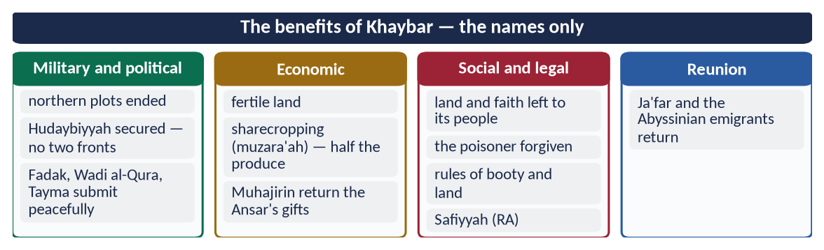
Figure 19 · At a glance — the benefits of Khaybar — the names only. The detail is in the sections above.

Part Two — Contemporary Challenges, Narratives and Hot Debates

12.1 The Prophet ﷺ as a model for a transnational, multicultural world
Migration, the internet and global trade have made every society mixed. The Sirah gives a working model: one political community with many faiths (the Charter), protection of the minority (the mu'ahad, Najran), dialogue on common ground (Aal-e-Imran 64), and identity without isolation — the Muslims of Abyssinia lived as a loyal minority under a Christian king. Muslims living as minorities in the West can follow the Abyssinian model; Muslim-majority states the Madinan model.
✦ QURAN
﴿يَـٰٓأَيُّهَا ٱلنَّاسُ إِنَّا خَلَقۡنَٰكُم مِّن ذَكَرٖ وَأُنثَىٰ وَجَعَلۡنَٰكُمۡ شُعُوبٗا وَقَبَآئِلَ لِتَعَارَفُوٓاْۚ إِنَّ أَكۡرَمَكُمۡ عِندَ ٱللَّهِ أَتۡقَىٰكُمۡۚ إِنَّ ٱللَّهَ عَلِيمٌ خَبِيرٞ﴾
“O mankind, indeed We have created you from male and female and made you peoples and tribes that you may know one another. Indeed, the most noble of you in the sight of Allah is the most righteous of you. Indeed, Allah is Knowing and Acquainted.” (Al-Hujurat, Quran)
➜ Nations and tribes exist to know one another — diversity is for recognition, not for conflict.

12.2 Responding to insults against the Prophet ﷺ — the lawful and dignified way
Caricatures and hateful attacks hurt every Muslim. The Sirah shows the response: firm love, lawful action, no violence against the innocent.
- (a) Allah Himself protects His Messenger: 'We are sufficient for you against the mockers' (Al-Hijr 95).
- (b) Taif and 'as-samu 'alaykum' — he answered insult with dignity and gentleness (Chapter 3).
- (c) Lawful, collective and diplomatic action by states: the OIC and Pakistan's initiative led the UN General Assembly to adopt 15 March as the International Day to Combat Islamophobia (Resolution 76/254, 2022).
- (d) The best answer is presenting the Sirah — knowledge removes the ignorance that feeds hatred.
TRAP · STAY WITHIN THE LAW
In the paper, condemn blasphemy firmly and present the lawful, state-led and diplomatic response; never write anything that seems to approve of mob violence or taking the law into one's own hands — the Sirah itself forbids it.

12.3 Leadership and management lessons from the Sirah
Modern management repeats Prophetic principles: vision (Hudaybiyyah seen as victory), consultation (Badr, Uhud, the Trench), the right person for the job (Khalid for command, Mu'adh for teaching, Dihya for Heraclius), delegation (governors and envoys), leading by example (the trench), merit over status (Usamah ibn Zayd, aged about 18, given command of an army that included senior Companions), and accountability ('each of you is a shepherd and each is responsible for his flock', Al-Bukhari and Muslim).

12.4 The Prophet ﷺ as educator in an age of AI and information overload
The problem today is not lack of information but lack of wisdom and character. The four functions of Al-Jumu'ah answer it: tilawah (sound content), tazkiyah (character), the Book (understanding) and wisdom (judgement). The Prophet's ﷺ method — verify before spreading — is the rule for social media:
✦ QURAN
﴿يَـٰٓأَيُّهَا ٱلَّذِينَ ءَامَنُوٓاْ إِن جَآءَكُمۡ فَاسِقُۢ بِنَبَإٖ فَتَبَيَّنُوٓاْ أَن تُصِيبُواْ قَوۡمَۢا بِجَهَٰلَةٖ فَتُصۡبِحُواْ عَلَىٰ مَا فَعَلۡتُمۡ نَٰدِمِينَ﴾
“O you who have believed, if there comes to you a disobedient one with information, investigate, lest you harm a people out of ignorance and become, over what you have done, regretful.” (Al-Hujurat, Quran)
➜ If a sinful person brings you news, verify it, lest you harm a people in ignorance.

✦ HADITH
كَفَى بِالْمَرْءِ كَذِبًا أَنْ يُحَدِّثَ بِكُلِّ مَا سَمِعَ
“It is enough of a lie for a man to repeat everything he hears.” (Muslim)
➜ The Prophetic rule against fake news.

12.5 Just war and the protection of civilians — the Sirah and modern humanitarian law
Principle of IHL | Geneva Conventions (1949) | The Sirah (7th century)
Distinction | Civilians must not be targeted | No women, children, old men, monks (Al-Bukhari; Muwatta)
Proportionality | No excessive force | 'Do not transgress' (Al-Baqarah 190); about 1,018 lives in ten years
Humane treatment of prisoners | Third Convention | Badr prisoners fed bread; freed for teaching
No perfidy | No treachery | 'Do not betray' (Muslim); Hudhayfah's promise kept
Protection of property and environment | Additional Protocols (1977) | No cutting of fruit trees, no destruction of towns
Diplomatic immunity | Vienna Convention (1961) | 'Envoys are not killed' (Abu Dawud)

DEBATE · DOES MODERN WAR RESPECT THESE RULES?
The destruction of civilian life in modern conflicts — Gaza is the clearest current example — shows that the world has written the rules but not kept them. The Prophetic model joined rule to practice: the commander himself answered for every breach (when Khalid killed the Banu Jadhimah wrongly, the Prophet ﷺ said, 'O Allah, I am free of what Khalid has done', and paid blood-money — Al-Bukhari).

Part Three — The Examiner's Record and Five Likely Questions

13.1 Every question on this topic, 2016–2025
Year | Question | Ch.
2016 Q4 | Describe the characteristics of Military strategist in the light of Sirah of Muhammad (PBUH) with arguments. | 6
2017 Q5 | Elucidate how the Prophet of Islam (PBUH) exemplified him as the greatest peace maker in the world by making reconciliation with pagans, Jews and Christians? | 8
2018 Q8 | The Holy Prophet (PBUH) is the prophet of peace and safety. Explain with arguments. | 8
2019 Q3 | Give a general estimate of Holy Prophet's (PBUH) character in the battle fields as commander. | 6
2020 Q2 | Discuss the status and grade of 'Tolerance and Forgiveness' in the life of the Holy Prophet (PBUH). | 3
2020 Q6 | Analyze the Madina Accord as a 'Social Contract' in detail. | 9
2021 Q8 | Notes: (a) Treaty of Hudaybiyya as a pact of peace; (b) Benefits acquired from the Battle of Khaybar. | 10, 11
2022 Q6 | Describe Hazrat Muhammad (ﷺ) as a Prophet of Peace for contemporary transnational world. | 8
2023 Q3 | Discuss the Holy Prophet's (ﷺ) Role as a Model for Military Strategy. | 6
2023 Q6 | Analyze the Charter of Madina as a social contract. | 9
2024 Q3 | The main purpose of Ghazwat-e-Nabawi was to establish peace. Explain. | 7
2025 Q2 | What is the importance of Makarim Akhlaq (noble morals) in establishing social peace? In this background, how did the Messenger of Allah complete these morals? | 3
2025 Q6 | Discuss the contents of the peace agreements made during the Prophet's era, identifying the parties to those agreements. | 10

All thirteen are answered in T3QA (ten model answers; three repeated questions share an answer).

13.2 What the record teaches
- Every paper from 2016 to 2025 has at least one Sirah question — 2020, 2023 and 2025 had two.
- Peace is the examiner's central theme; even the military questions of 2024 turn to peace.
- Questions repeat almost word for word (Charter 2020 and 2023; military 2016 and 2023).
- Educator, Diplomat and the Individual have never been asked — they are due.

13.3 Five likely questions
1. The Holy Prophet ﷺ was the greatest teacher of humanity. Discuss his role as an educator, with his methods of teaching.
2. Describe the diplomacy of the Holy Prophet ﷺ with reference to his letters to the rulers, envoys and treaties.
3. The life of the Holy Prophet ﷺ is a perfect model for the individual. Explain.
4. Discuss the Conquest of Makkah as the greatest example of forgiveness and peace in history.
5. Analyse the principles of war and peace laid down by the Holy Prophet ﷺ and their relevance to modern international humanitarian law.

Part Four — The One-Liner Bank

One-liners · The Sirah and its sources
1. Sirah literally means 'way of going'; technically, the life of the Prophet ﷺ.
2. 'You have in the Messenger of Allah an excellent example' — Al-Ahzab.
3. The Uswah Hasanah verse came during the Battle of the Trench.
4. 'You are of a great moral character' — Al-Qalam.
5. 'His character was the Quran' — Hazrat Aishah (RA), Muslim.
6. He was sent as a mercy to all the worlds — Al-Anbiya.
7. He is the Seal of the Prophets — Al-Ahzab.
8. The first complete Sirah: Muhammad ibn Ishaq (d. 151 AH).
9. The standard edited Sirah: Ibn Hisham (d. 218 AH).
10. Kitab al-Maghazi: Al-Waqidi; Al-Tabaqat al-Kubra: Ibn Sa'd.
11. Al-Shama'il al-Muhammadiyyah: Imam al-Tirmidhi.
12. Sirat-un-Nabi: Shibli Nomani and Syed Sulaiman Nadvi.
13. Rahmatul-lil-Alamin: Qazi Muhammad Sulaiman Mansurpuri.
14. Al-Raheeq al-Makhtum: Safi-ur-Rahman Mubarakpuri — first prize, Muslim World League, 1979.
15. Nadvi's four tests: historical, comprehensive, complete, practical.
16. The 100 (1978), placing the Prophet ﷺ first: Michael H. Hart.

One-liners · The individual
17. 'Should I not be a grateful servant?' — on standing in prayer till his feet swelled (Al-Bukhari and Muslim).
18. 'Tie it and trust in Allah' — Al-Tirmidhi.
19. His titles before Prophethood: Al-Sadiq, Al-Amin.
20. The testimony of truthfulness was given on the hill of Safa.
21. Ali (RA) returned the trusts of the Quraysh after the Hijrah.
22. 'The best of you is the best to his family' — Al-Tirmidhi.
23. 'He used to be in the service of his family' — Hazrat Aishah (RA), Al-Bukhari.
24. 'I and the guardian of an orphan will be like these two in Paradise' — Al-Bukhari.
25. His freed slave who chose him over his own father: Zayd ibn Harithah (RA).
26. 'Purity is half of faith' — Muslim.
27. Two blessings most people waste: health and free time — Al-Bukhari.
28. 'The religion is easy' — Al-Bukhari.

One-liners · Makarim al-Akhlaq, tolerance and forgiveness
29. 'I was sent to perfect the noblest morals' — Al-Bayhaqi and Ahmad.
30. 'Nothing is heavier in the Scale than good character' — Abu Dawud and Al-Tirmidhi.
31. 'Take to forgiveness, enjoin good, turn from the ignorant' — Al-A'raf.
32. 'Repel evil with what is better' — Fussilat.
33. 'Those who restrain anger and pardon people' — Aal-e-Imran.
34. Grades of tolerance: sabr → kazm al-ghayz → hilm → 'afw → safh → ihsan.
35. He never took revenge for himself — Hazrat Aishah (RA), Al-Bukhari and Muslim.
36. At Taif he prayed for the descendants of his attackers.
37. 'I was not sent to curse; I was sent as a mercy' — Muslim.
38. 'No blame upon you today' — the words of Prophet Yusuf, repeated at Makkah.
39. 'Go, you are free' (antum al-tulaqa') — the Makkah amnesty.
40. Forgiven at Makkah: Hind, Wahshi, Ikrimah, Safwan, Habbar.
41. The woman who poisoned him at Khaybar was not punished for his own sake.
42. 'You were sent to make things easy' — on the Bedouin in the mosque (Al-Bukhari).
43. 'Allah loves gentleness in every matter' — to Hazrat Aishah (RA).
44. 'Is it not a soul?' — standing for a Jewish funeral.
45. Whoever kills a mu'ahad will not smell Paradise — Al-Bukhari.
46. The Christians of Najran prayed in the Mosque of Madinah.
47. Reconciling people is better than voluntary fasting, prayer and charity — Abu Dawud.

One-liners · Educator
48. The first revealed word: Iqra (Read) — Al-Alaq.
49. 'My Lord, increase me in knowledge' — Taha.
50. His four functions — recite, purify, teach the Book, teach wisdom — Al-Jumu'ah.
51. 'Allah sent me as a teacher who makes things easy' — Muslim.
52. 'Seeking knowledge is obligatory on every Muslim' — Ibn Majah.
53. The first centre of learning in Makkah: Dar al-Arqam.
54. The first teacher sent to Yathrib: Mus'ab ibn Umair (RA).
55. The residential school in the Mosque of Madinah: Suffah.
56. The most famous student of the Suffah: Abu Hurairah (RA).
57. Each literate prisoner of Badr taught ten children to read and write.
58. Zayd ibn Thabit (RA) learnt the Jewish script at the Prophet's ﷺ order.
59. 'I never saw a better teacher' — Mu'awiyah ibn al-Hakam (RA), Muslim.
60. 'Do you know who the bankrupt is?' — teaching by question (Muslim).
61. He repeated important words three times — Al-Bukhari.
62. 'Pray as you have seen me pray' — demonstration (Al-Bukhari).
63. Gradual teaching: instructions to Mu'adh (RA) for Yemen.
64. 'Convey from me, even one verse' — Al-Bukhari.

One-liners · Diplomat
65. Pre-Prophethood pact to protect the wronged: Hilf al-Fudul, in the house of Abdullah ibn Jud'an.
66. The Black Stone dispute was settled with his cloak (605).
67. The first Hijrah, to Abyssinia, was in 615.
68. The Muslims' spokesman before the Negus: Ja'far ibn Abi Talib (RA).
69. The letters to the rulers were sent in 6–7 AH, after Hudaybiyyah.
70. His seal read 'Muhammad Rasul Allah'.
71. Envoy to Heraclius: Dihya al-Kalbi (RA).
72. Envoy to Khusrau Parvez: Abdullah ibn Hudhafah (RA); the letter was torn.
73. Envoy to the Muqawqis of Egypt: Hatib ibn Abi Balta'ah (RA).
74. 'Aslim taslam' — accept Islam and you will be safe (letter to Heraclius).
75. The verse quoted in the letter to Heraclius: Aal-e-Imran 64.
76. 'Were it not that envoys are not killed…' — to Musaylimah's envoys (Abu Dawud).
77. 9 AH is the Year of Delegations ('Am al-Wufud).
78. 'The first written constitution of the world' — Dr Muhammad Hamidullah.

One-liners · Military strategist and the Ghazwat
79. First permission to fight: Al-Hajj 39.
80. Ghazwah = led by him (about 27); Sariyyah = sent under a Companion.
81. Badr (2 AH): 313 Muslims against about 1,000.
82. The Companion who advised the position at the wells of Badr: Hubab ibn al-Mundhir (RA).
83. Uhud (3 AH): 50 archers under Abdullah ibn Jubayr (RA).
84. The lesson of Uhud — dispute and disobedience — Aal-e-Imran 152.
85. The trench was the idea of Salman al-Farisi (RA).
86. Khandaq (5 AH): 3,000 Muslims against about 10,000 Confederates.
87. The Companion who split the Confederates: Nu'aym ibn Mas'ud (RA).
88. 'War is stratagem' — Al-Bukhari and Muslim.
89. The Conquest of Makkah (8 AH) with 10,000; ten thousand fires at night.
90. Hunayn (8 AH): 'I am the Prophet, no lie; I am the son of Abd al-Muttalib'.
91. Tabuk (9 AH): 30,000 — no battle.
92. Pursuit after Uhud: Hamra al-Asad.
93. 'Do not wish to meet the enemy; ask Allah for safety' — Al-Bukhari and Muslim.
94. Total lives lost in his battles: about 1,018 — Qazi Sulaiman Mansurpuri.
95. The Battlefields of the Prophet Muhammad: Dr Muhammad Hamidullah.

One-liners · Peace maker, the Charter and the treaties
96. 'The Muslim is one from whose tongue and hand Muslims are safe' — Al-Bukhari and Muslim.
97. 'The believer is one whom people trust with their lives and property' — Al-Tirmidhi.
98. Last battle of Aws and Khazraj before the Hijrah: Bu'ath (617).
99. The brotherhood of Muhajirin and Ansar: Mu'akhat.
100. The first blood-claim abolished at the Farewell Sermon: of Ibn Rabi'ah ibn al-Harith.
101. 'No Arab has superiority over a non-Arab except by taqwa' — the Farewell Sermon.
102. The Charter of Madinah: 1 AH / 622; about 47–53 clauses.
103. 'To the Jews their religion and to the Muslims theirs' — the Charter.
104. In the Charter, disputes are referred to Allah and Muhammad ﷺ.
105. In the Charter, Yathrib is declared a sanctuary (haram).
106. Leviathan (1651): Hobbes; Two Treatises (1689): Locke; The Social Contract (1762): Rousseau.
107. Hudaybiyyah: Dhul Qa'dah 6 AH, with about 1,400 Companions.
108. The Quraysh negotiator at Hudaybiyyah: Suhayl ibn Amr.
109. The pledge under the tree: Bay'at al-Ridwan — Al-Fath 18.
110. Hudaybiyyah's truce: ten years.
111. Hudaybiyyah was called 'a clear victory' — Al-Fath 1.
112. Returned in chains under the treaty: Abu Jandal (RA).
113. The first treaty with a non-Muslim tribe: Banu Damrah (2 AH).
114. Christian ruler of Aylah given a covenant at Tabuk: Yuhanna ibn Ru'bah.
115. Khaybar (7 AH): about 1,600 Muslims; eight forts.
116. Khaybar land left with its people for half the produce — sharecropping (muzara'ah).
117. 'I do not know which makes me happier — Khaybar or the arrival of Ja'far'.
118. International Day to Combat Islamophobia: 15 March (UN, 2022).
ONE-LINER COUNT
This topic carries 118 one-liners, numbered 1–118. Revise them in blocks of twenty; tick the ones you can answer without looking.

Part Five — Revision Notes · Topic 3
Read these on the night before the paper. Each chapter is compressed into chains (→) and short lists; every line should unlock a heading you have already studied.

R3.0 The topic in eleven lines
1. Sirah → the life as guidance → Uswah Hasanah (Al-Ahzab) → Nadvi's four tests: historical · comprehensive · complete · practical.
2. Individual → grateful worship · Al-Amin · the mat · best to family · orphans · work · purity · moderation.
3. Makarim al-Akhlaq → 'sent to perfect' → completed six ways → tolerance grades → Taif, Makkah, poison, Bedouin → social peace.
4. Educator → Al-Jumu'ah: recite · purify · Book · wisdom → Arqam, Suffah, Badr prisoners → gentle methods.
5. Diplomat → Hilf al-Fudul, Black Stone → Abyssinia → treaties → letters to eight rulers → immunity of envoys → delegations.
6. Strategist → preparation · intelligence · shura · ground · discipline · rows · trench · surprise · alliances · minimum force.
7. Commander → front line · sharing · humility · integrity · mercy · 'do not wish for the enemy'.
8. Ghazwat → permission after persecution → only against fighters → rules → 1,018 lives → safe roads.
9. Peace maker → salam → Aws–Khazraj → Mu'akhat → pagans, Jews, Christians → transnational world.
10. Charter → state of nature → one Ummah → religious freedom → arbiter → defence → sanctuary → social contract beyond Hobbes, Locke, Rousseau.
11. Hudaybiyyah → 'defeat' on paper → clear victory → recognition, dawah, letters, Khaybar, Makkah; the pacts table; Khaybar's benefits.

R3.1 Chapter 1 · The Sirah and the Uswah Hasanah
- (i) Meaning: sirah → sara, to go → way of life → the recorded life of the Prophet ﷺ as guidance.
- (ii) Quranic basis: Uswah Hasanah (Al-Ahzab, at the Trench) → great character (Al-Qalam) → obey him = obey Allah (An-Nisa) → not from desire (An-Najm) → mercy to all (Al-Anbiya) → Seal (Al-Ahzab).
- (iii) Aishah: 'his character was the Quran' (Muslim).
- (iv) Sources: Quran → Hadith + Shama'il (Tirmidhi) → Maghazi: Urwah → Zuhri → Ibn Ishaq → Ibn Hisham; Waqidi, Ibn Sa'd → Qadi Iyad, Ibn al-Qayyim → modern: Shibli–Nadvi, Mansurpuri, Mubarakpuri, Hamidullah, Lings.
- (v) Why universal: Nadvi's four tests — historical (recorded), comprehensive (every role), complete (private + public), practical (lived it) → Hart: 'supremely successful on religious and secular levels'.
- (vi) Trap: not a biography → events as proof of the role asked.

R3.2 Chapter 2 · The individual
- (i) Worship: night prayer → 'a grateful servant' → tawakkul after means: 'tie it' → cave of Thawr.
- (ii) Truth and trust: Safa testimony → trusts returned by Ali (RA) on the Hijrah night.
- (iii) Simplicity: the mat → Umar weeps → 'they have this world, we the Hereafter' → dates and water → armour pledged for barley.
- (iv) Family: 'best to his family' → served at home → Fatimah, Hasan, Husain → tears for Ibrahim.
- (v) The weak: orphans 'like these two' → mercy to young, respect to old → Zayd ibn Harithah.
- (vi) Work: 'food of one's own hands' → shepherd, trader, builder, trench digger.
- (vii) Health and time: purity half of faith → health and free time → moderate eating, early sleep.
- (viii) Moderation and manners: 'religion is easy' → middle nation → never cursed → golden rule.
- (ix) Pakistan: love without following → the gap in honesty, punctuality, cleanliness.

R3.3 Chapter 3 · Makarim al-Akhlaq, tolerance and forgiveness
- (i) Meaning: akhlaq → khuluq → settled state (Ghazali) → makarim = the noblest: forgive, give, join.
- (ii) Purpose: 'sent to perfect noble morals' → best in character = best (Al-Bukhari) → heaviest in the Scale.
- (iii) Completed six ways: new root (for Allah) → universal (tribe → humanity) → to enemies (Al-Ma'idah 8) → balanced → demonstrated → institutionalised.
- (iv) Quranic command: take to forgiveness (Al-A'raf) → gentleness (Aal-e-Imran 159) → repel evil with good (Fussilat).
- (v) Grades: sabr → kazm al-ghayz → hilm → 'afw → safh → ihsan; never revenge for himself.
- (vi) Examples: Taif (hope for descendants) → 'not sent to curse' → Makkah: 'no blame today … go, you are free' → Hind, Wahshi, Ikrimah, Habbar → poison at Khaybar → Bedouin in mosque → pulled cloak → 'as-samu 'alaykum' → Ibn Ubayy's funeral.
- (vii) Trap: old woman with rubbish — no authentic source.
- (viii) Other faiths: no compulsion → 'for you your religion' → justice to the non-hostile → 'is it not a soul?' → Najran → mu'ahad.
- (ix) Social peace: truth → trust → justice → forgiveness → mercy → modesty → brotherhood → tongue control; anger control; reconciling better than nafl → Basus/Bu'ath → 'He brought your hearts together'.

R3.4 Chapter 4 · Educator
- (i) Basis: Iqra and the pen (Al-Alaq) → 'increase me in knowledge' (Taha) → four functions (Al-Jumu'ah) → 'sent as a teacher' (Muslim) → knowledge a duty (Ibn Majah).
- (ii) Four functions: tilawah (content) → tazkiyah (character) → the Book (meaning) → wisdom (application).
- (iii) Institutions: Dar al-Arqam → Mus'ab to Yathrib → Suffah (Abu Hurairah) → Badr prisoners teach ten → scribes, Zayd learns a language → teachers to Yemen; Bi'r Ma'unah.
- (iv) Methods: gentleness (Mu'awiyah ibn al-Hakam) → easy, good news → questions (the bankrupt) → repetition ×3 → demonstration (pray as I pray) → drawings, parables → gradualism (Mu'adh) → spacing (Ibn Mas'ud) → individual differences → women's day → example → 'convey even one verse'.
- (v) Result: Ibn Abbas, Ibn Mas'ud → Kufa → Abu Hanifah; Zayd, Aishah, Mu'adh.
- (vi) Pakistan: 26 million out of school → Article 25-A → character + information, no corporal punishment, women's education.

R3.5 Chapter 5 · Diplomat
- (i) Principles: wisdom (An-Nahl) → incline to peace (Al-Anfal) → keep covenants (Al-Isra) → common word (Aal-e-Imran 64).
- (ii) Before Prophethood: Hilf al-Fudul ('I would accept it in Islam') → Black Stone and the cloak.
- (iii) Asylum: Abyssinia (615) → Ja'far and Surah Maryam → Negus refuses extradition.
- (iv) Treaties: Aqabah → Charter → Banu Damrah → Hudaybiyyah → Tabuk.
- (v) Letters (6–7 AH): seal 'Muhammad Rasul Allah' → Heraclius (Dihya; 'aslim taslam'; Abu Sufyan questioned) → Khusrau (tore it) → Muqawqis (gifts) → Negus → Ghassan → Bahrain, Oman (accepted) → Yamamah.
- (vi) Features: Bismillah → respectful titles → brief → right envoy → peace offered → ruler's responsibility → sealed.
- (vii) Envoys and delegations: 'envoys are not killed' → Year of Delegations (9 AH) → Najran, Thaqif → gifts.
- (viii) Scholar: Hamidullah → siyar, Islamic international law.

R3.6 Chapter 6 · Military strategist and commander
- (i) Background: 13 years no fighting → Al-Hajj 39 → head of state defends it.
- (ii) Numbers: about 27 ghazwat, fighting in about 9; 50–60 saraya.
- (iii) Battles: Badr 313 v 1,000 → Uhud 700 v 3,000 → Khandaq 3,000 v 10,000 → Khaybar 1,600 → Makkah 10,000 → Hunayn 12,000 v 20,000 → Tabuk 30,000.
- (iv) Principles: preparation and deterrence (Al-Anfal 60) → intelligence (water-carriers) → shura (Hubab, majority at Uhud, Salman) → ground (wells, archers' hill) → discipline (Al-Anfal 46; Uhud lesson) → rows (As-Saff) → trench → split alliances (Nu'aym) + 'war is stratagem' → secrecy and ten thousand fires → economic pressure → alliances, no two fronts → speed (Hamra al-Asad) → morale → minimum force (1,018).
- (v) Commander's character (2019): courage ('we sheltered behind him'; Hunayn 'no lie') → sharing (trench, hunger stone) → humility → trust + preparation → keeping word (Hudhayfah) → justice (Sawad) → mercy (prisoners, Hawazin) → forgiveness (Makkah) → patience (after Uhud) → 'do not wish to meet the enemy'.
- (vi) Writers: Glubb Pasha → Hamidullah's battlefields.
- (vii) Examiner: principles for 2016/2023; personal qualities for 2019.

R3.7 Chapter 7 · War for peace
- (i) Terms: jihad = striving (wide) → qital = fighting (narrow).
- (ii) Quranic conditions: after persecution (Al-Hajj 39–40: all houses of worship) → only fighters (Al-Baqarah 190) → end fitnah (193) → for the oppressed (An-Nisa 75) → peace when offered (Al-Anfal 61; An-Nisa 90).
- (iii) Causes: Badr, Uhud, Khandaq = defence → Khaybar = conspiracy → Makkah = broken treaty → Hunayn = attack → Tabuk = border.
- (iv) Rules: Buraydah: no theft, treachery, mutilation, killing children; invite first → no women, children → Abu Bakr: no old men, fruit trees, towns → At-Tawbah 6.
- (v) Results: 259 + 759 = 1,018 → 1 million sq. miles → WWI 17 m, WWII 70–85 m → 'one man guided better than red camels' → Adi ibn Hatim: safe road Hira–Ka'bah → enemies became allies.
- (vi) Trap: 'spread by the sword' → no compulsion; Indonesia, Malaysia; growth after Hudaybiyyah.

R3.8 Chapter 8 · Peace maker
- (i) Salam: Islam–salam, s-l-m → As-Salam, Dar as-Salam → mercy (Al-Anbiya).
- (ii) Peace and safety: safe from tongue and hand → trusted by people (an-nas) → spread salam → one life = all mankind (Al-Ma'idah 32).
- (iii) Before Prophethood: Hilf al-Fudul → Black Stone → Al-Amin.
- (iv) Madinah: Bu'ath → hearts joined (Aal-e-Imran 103) → Mu'akhat (Al-Hashr 9) → blood feuds abolished, from his own family → lives and property sacred → no racial superiority → reconciling (Al-Hujurat 9; Quba).
- (v) Pagans: patience → Taif → Hudaybiyyah ('any plan respecting the sacred') → Makkah safe-houses → Hawazin captives.
- (vi) Jews: Charter → Tu'mah case → Khaybar sharecropping → sick boy, funeral → tribes left only after breach.
- (vii) Christians: Negus, funeral in absence → Najran treaty → Aylah → common word; Al-Ma'idah 82.
- (viii) Transnational (2022): dignity (UDHR) → treaties (UN Charter) → refugees (1951) → minorities (Art. 36) → dialogue (Amman Message, A Common Word) → IHL (Geneva) → immunity (Vienna 1961) → economic justice (SDGs) → environment (Paris) → Al-Hujurat 13 → Shaw.

R3.9 Chapter 9 · Charter of Madinah as social contract
- (i) What: Mithaq / Sahifat al-Madinah → 1 AH/622 → 47–53 clauses → Ibn Ishaq, Abu Ubayd → Hamidullah: first written constitution.
- (ii) Background = state of nature: tribal war (Bu'ath) → no state, court or law → mixed people → Quraysh threat.
- (iii) Parties: Muhajirin → Ansar (Aws, Khazraj) → Jewish tribes → allies and clients.
- (iv) Provisions: one Ummah → religious freedom → refer to Allah and Muhammad ﷺ → joint defence, own expenses → Yathrib sanctuary → guilt personal → justice even against one's son → blood-money by clans → no protection to Quraysh.
- (v) Social contract: Hobbes (security) → Locke (rights, limited power) → Rousseau (general will).
- (vi) Elements mapped: state of nature → consent → sovereign → rights → duties → rule of law → written.
- (vii) Beyond the West: real not hypothetical → divine sovereignty → pluralism before 1648 → moral basis.
- (viii) In operation: Qaynuqa, Nadir, Qurayzah → breach → dealt with under the contract.
- (ix) Pakistan: Objectives Resolution → Articles 20, 36 → federation.

R3.10 Chapter 10 · Hudaybiyyah and the peace agreements
- (i) Hudaybiyyah: 6 AH, 1,400, Umrah in ihram → Uthman rumour → Bay'at al-Ridwan (Al-Fath 18) → Suhayl → 'Bismika Allahumma', 'Muhammad ibn Abdullah'.
- (ii) Terms: 10-year truce → return now, Umrah next year 3 days → Makkan fugitives returned, not vice versa → free alliances (Khuza'ah / Banu Bakr).
- (iii) Grief: Umar: 'are we not on the truth?' → Abu Jandal returned.
- (iv) Clear victory (Al-Fath 1): recognition → dawah (Zuhri; 1,400 → 10,000) → Khalid, Amr → letters, Khaybar → Abu Basir → Quraysh breach → Makkah.
- (v) Lessons: patience → flexible form, firm principle → word kept → long vision → peace as strategy.
- (vi) Pacts table: Hilf al-Fudul (Quraysh clans) → Aqabah (Aws, Khazraj) → Charter → Banu Damrah (first) → Mudlij, Juhaynah → Hudaybiyyah (Quraysh) → Khaybar, Fadak (half produce) → Tabuk: Aylah etc. (jizyah, protection) → Najran (churches, 2,000 robes) → Thaqif.

R3.11 Chapter 11 · Khaybar and its benefits
- (i) Background: 150 km north → eight forts → Banu Nadir leaders → organised the Ahzab → allied with Ghatafan.
- (ii) Campaign: Muharram 7 AH → 1,600 v 10,000 → cut off Ghatafan → fort by fort → flag to Ali: 'invite first'.
- (iii) Military/political: northern plots ended → no two fronts → Fadak, Wadi al-Qura, Tayma submit → Muslims the leading power.
- (iv) Economic: fertile land → sharecropping, half produce → Muhajirin return Ansar's palms.
- (v) Social/legal: land and faith left → poisoner forgiven → rules of booty and land; donkey meat forbidden → Safiyyah (RA).
- (vi) Reunion: Ja'far returns — 'which makes me happier?'

R3.12 Part Two · Today
Transnational world → Abyssinian and Madinan models · insults → Al-Hijr 95, gentleness, OIC, 15 March, no mob violence · leadership → vision, shura, merit (Usamah), accountability · AI age → verify (Al-Hujurat 6), 'repeating all one hears is a lie' · IHL → distinction, proportionality, prisoners, no perfidy, environment, immunity; Khalid and Banu Jadhimah.

R3.13 The figures to draw
The five-roles wheel; the timeline (570 · 610 · 622 · 624 · 628 · 630 · 632); the Ghazwat bar chart; why–how–what of war for peace; the Charter chart (parties + six provisions); Hudaybiyyah terms → results; the letters map.

